# **Logistic Regression as a Neural Network**



Lets take the below example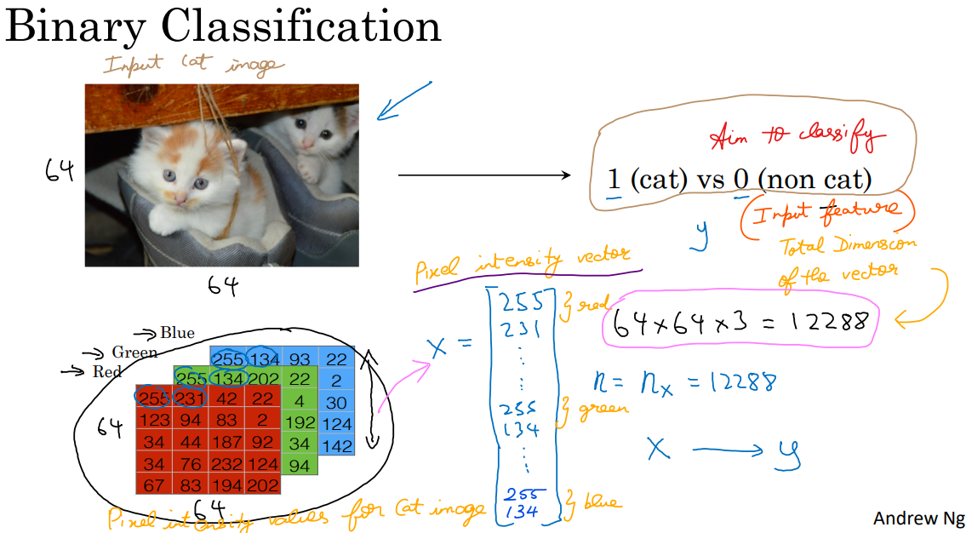

Single image is 64*64 pixels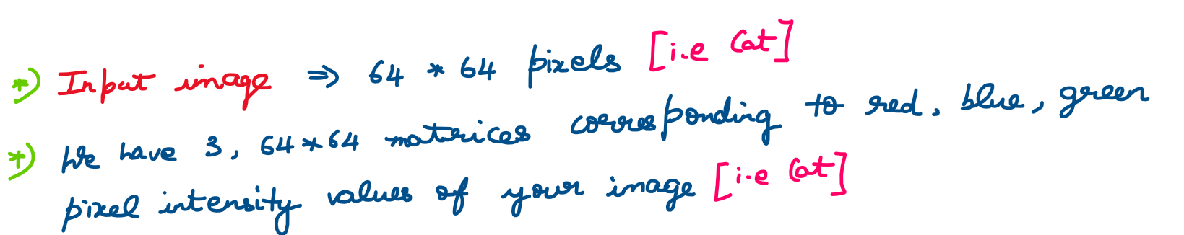

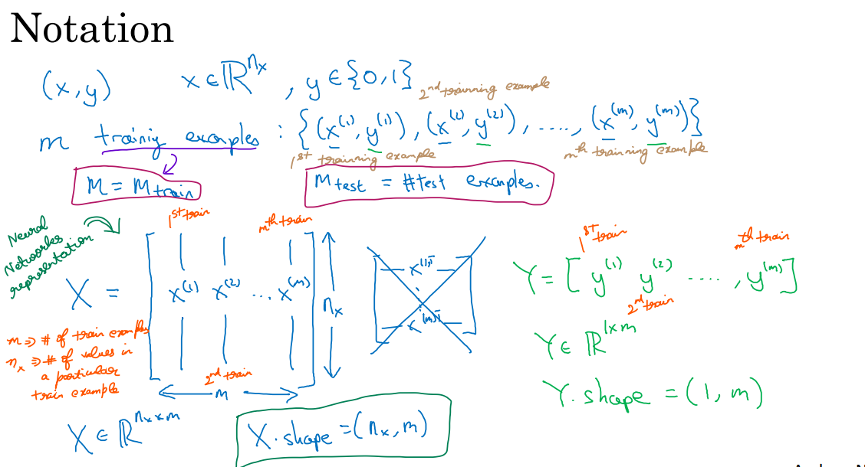

## **Logistic Regression**

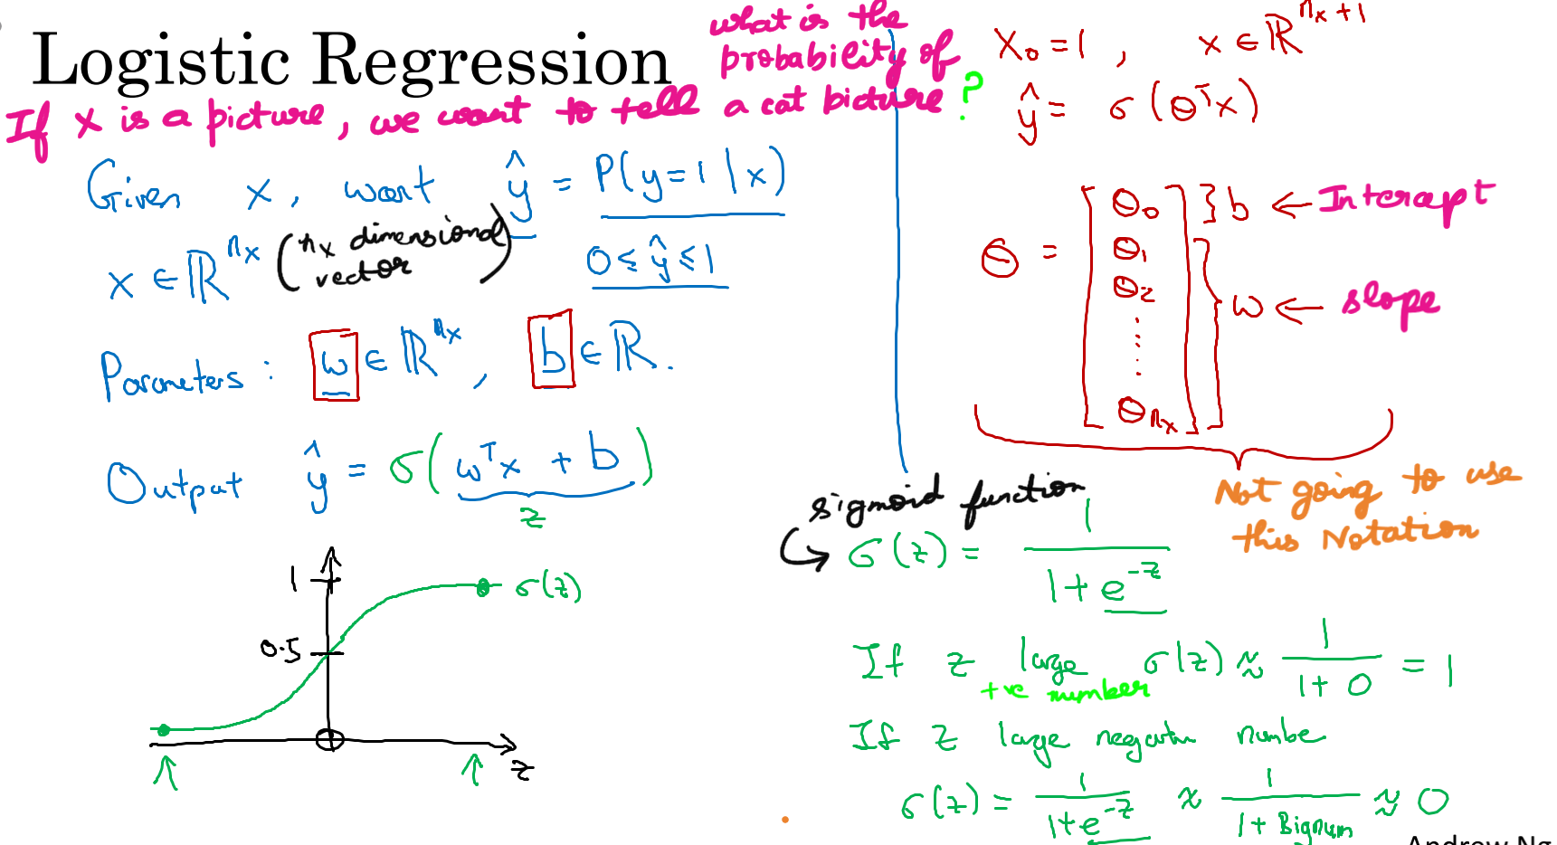

## **Logistic Regression Cost Function**

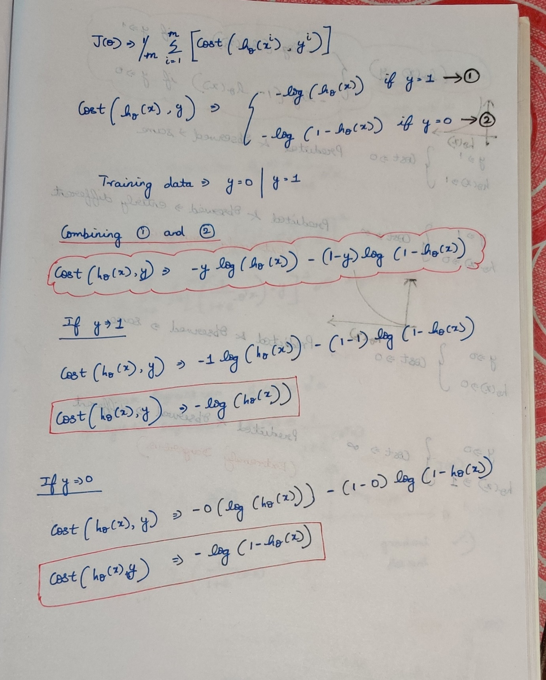

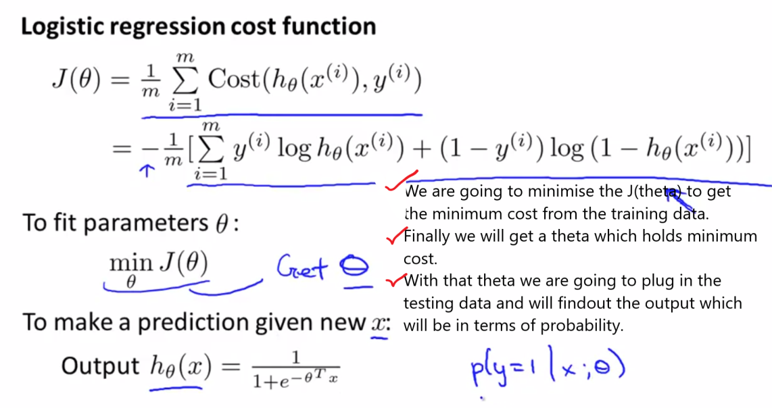  
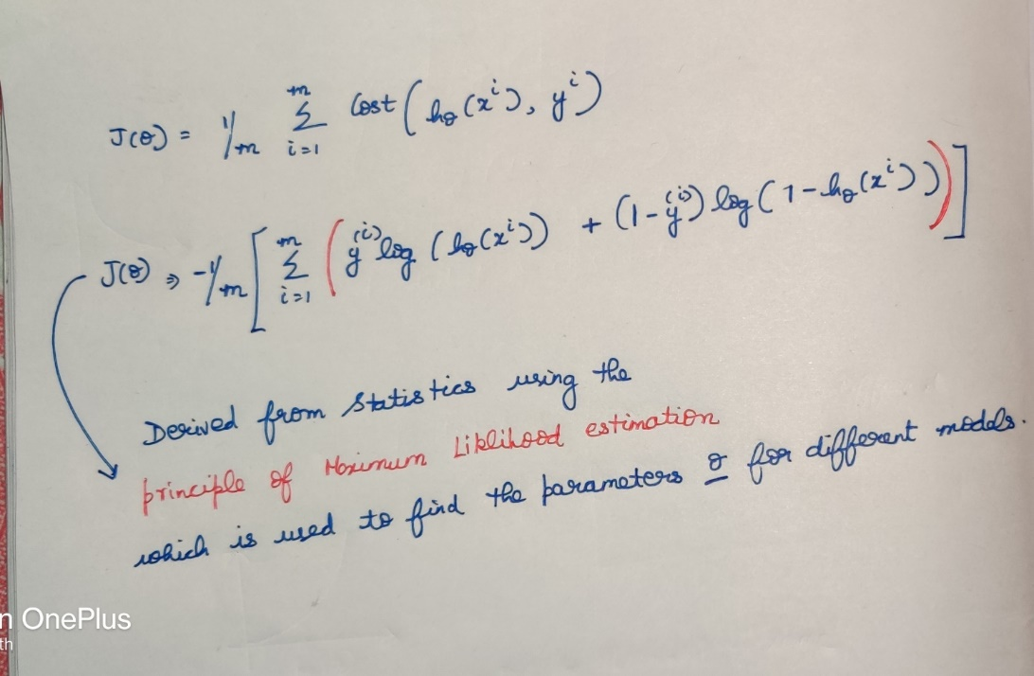  
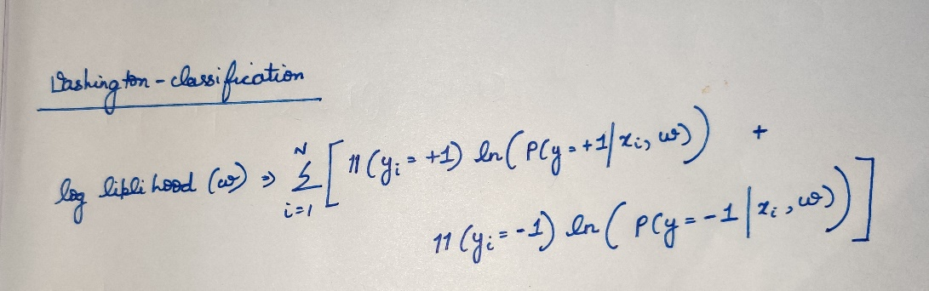  
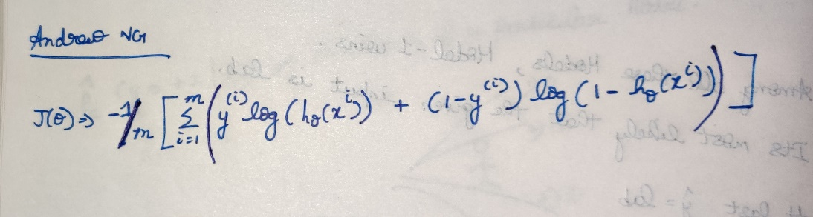

 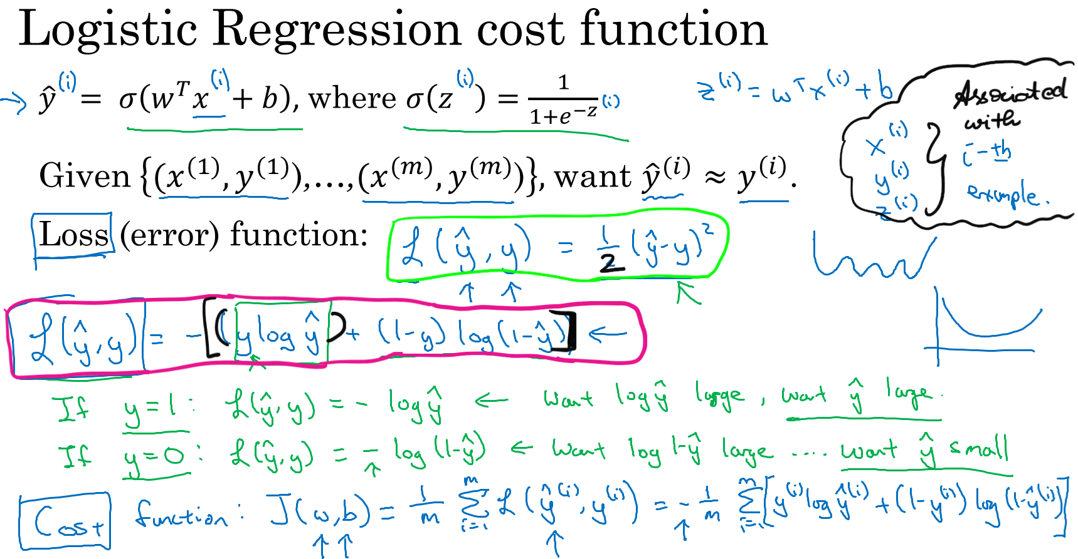

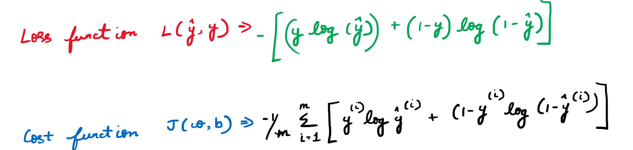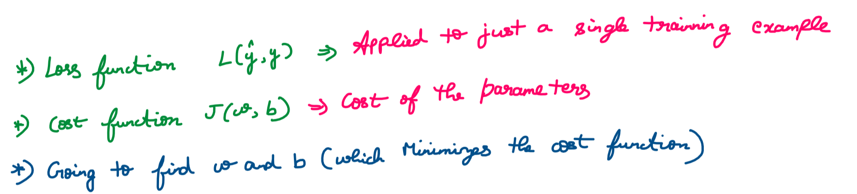

## **Gradient Descent**

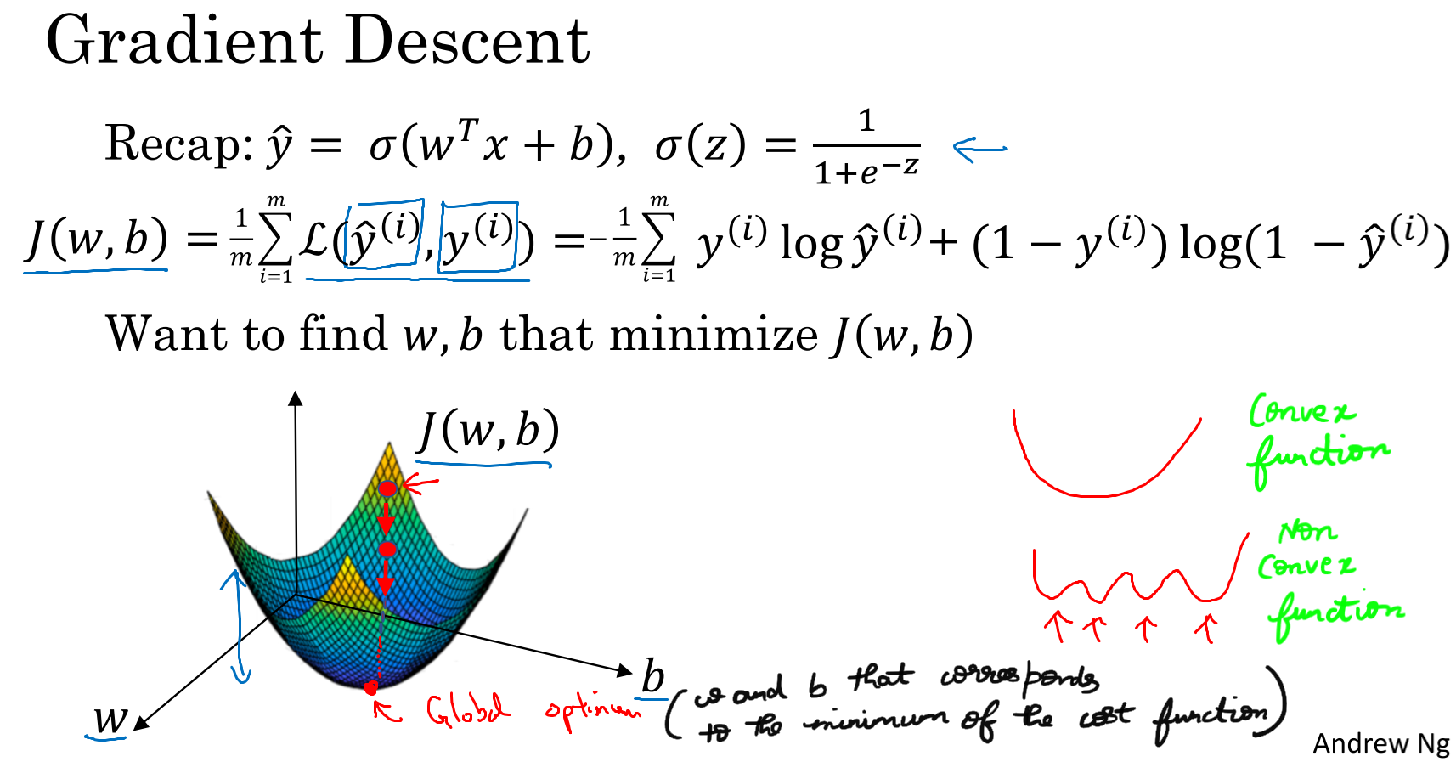  
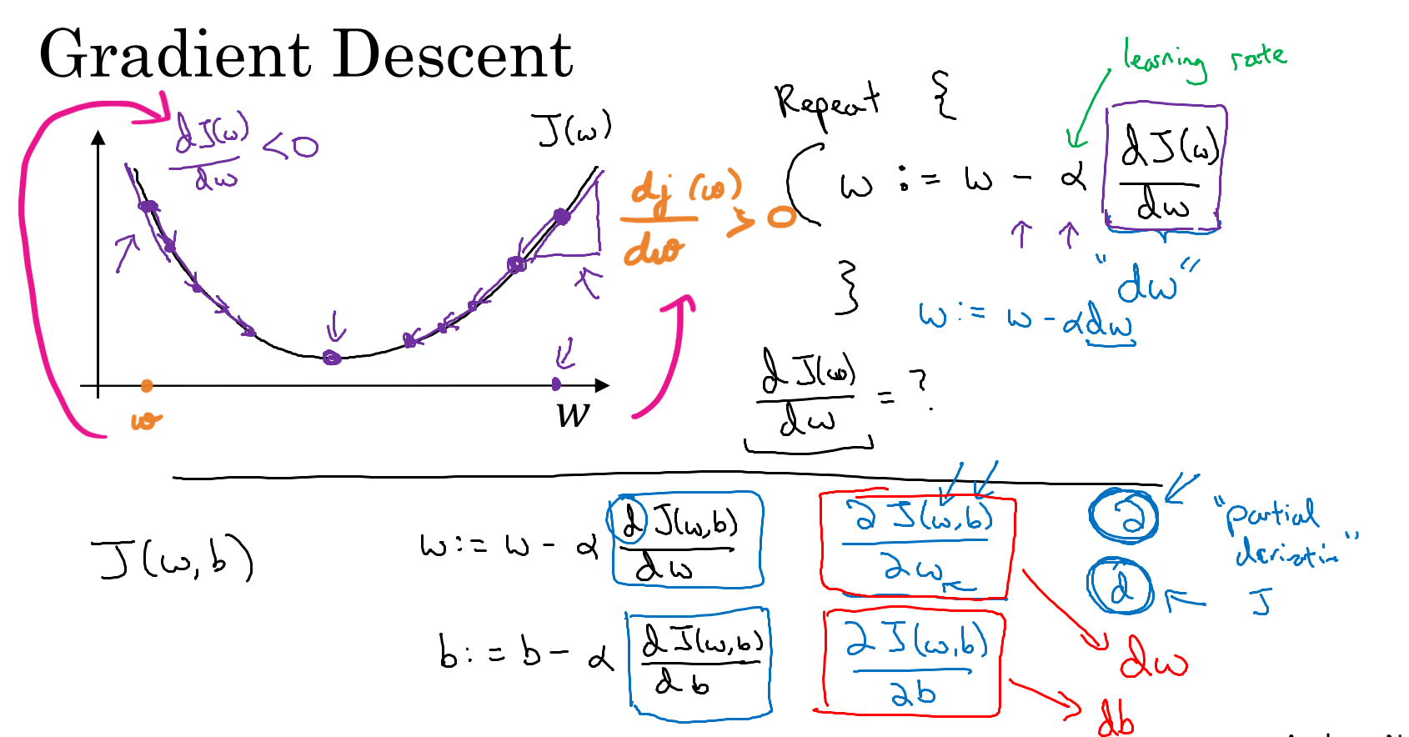

## **Derivatives**

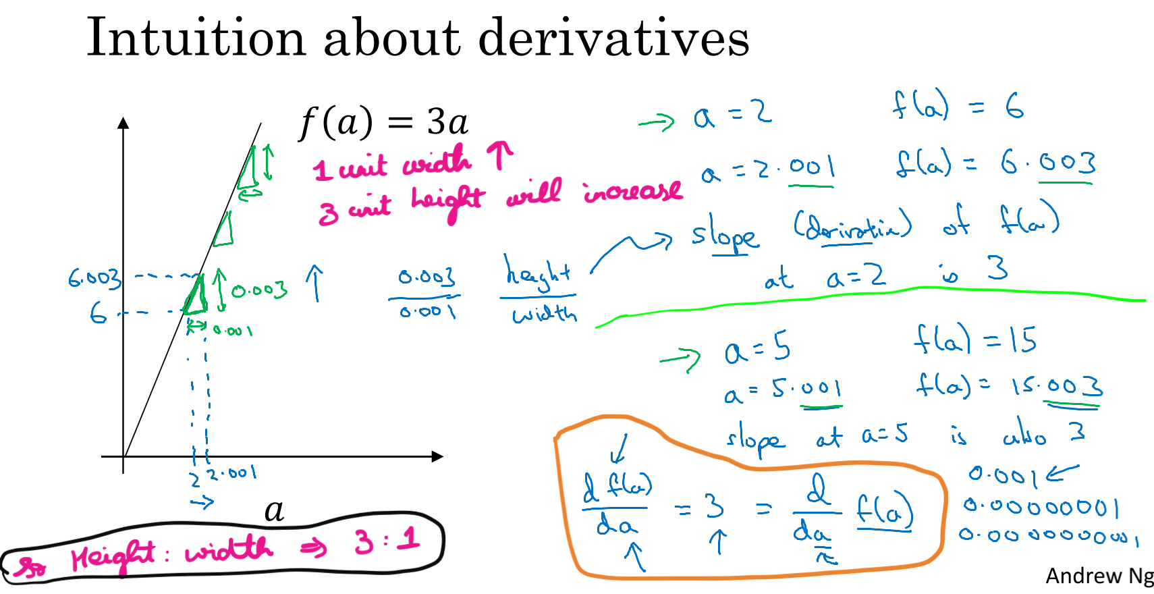

## **Derivatives Example**

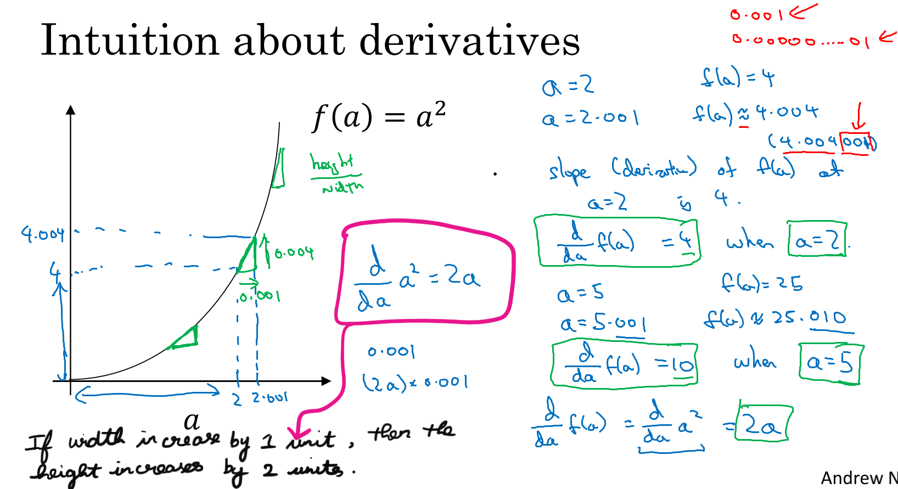

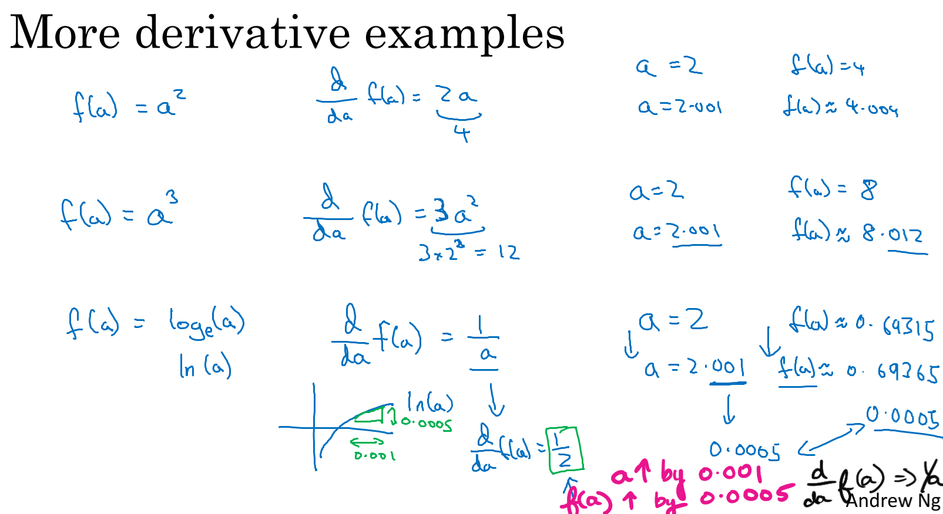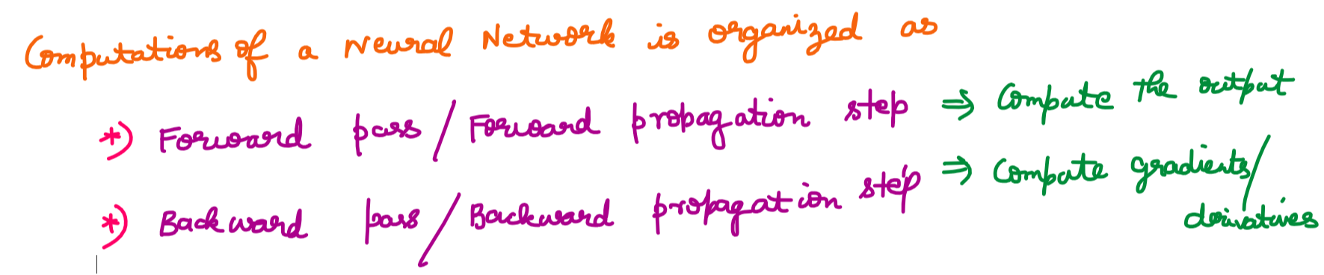

## **Computation Graph**

A computational Graph explains why this passes/propagation steps are organized in this way.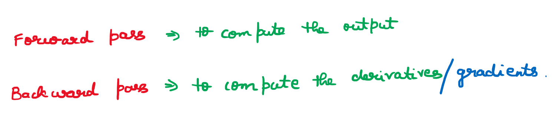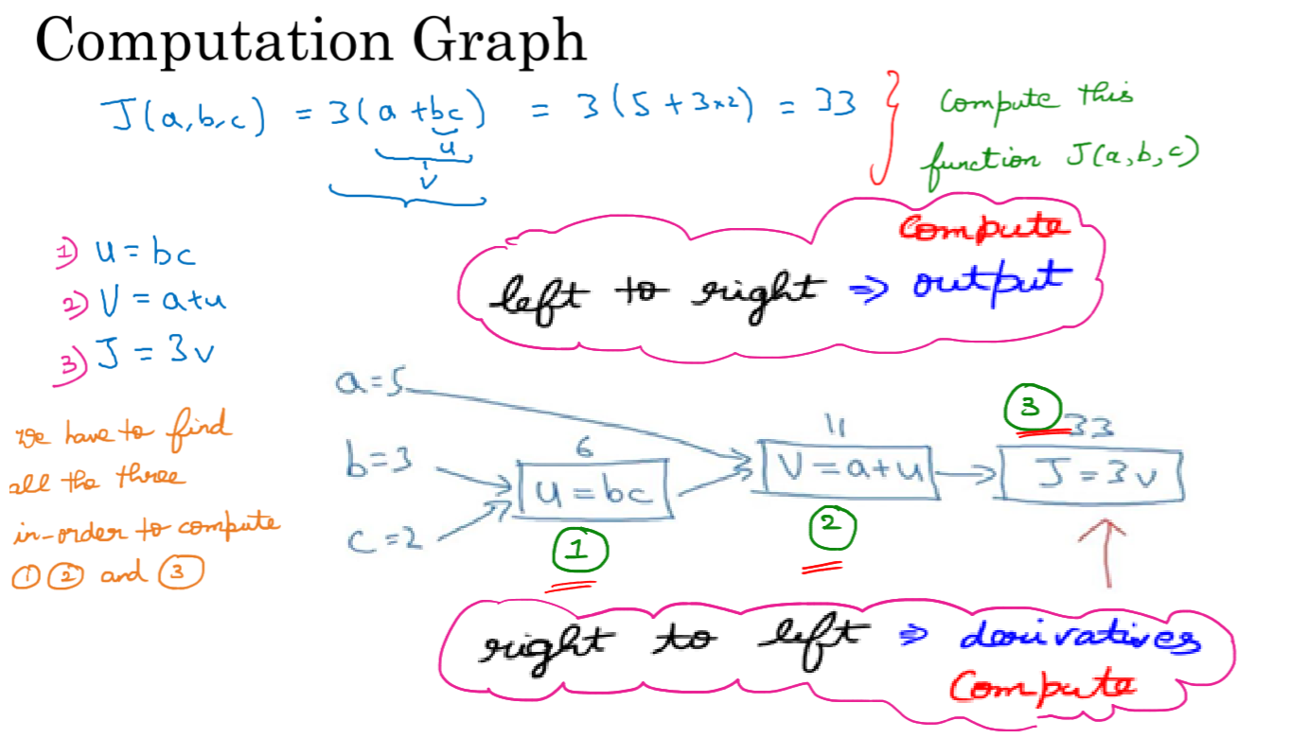

## **Derivatives of Computation graph**

Lets compute the derivative of the function J.   
Lets compute dj/dv.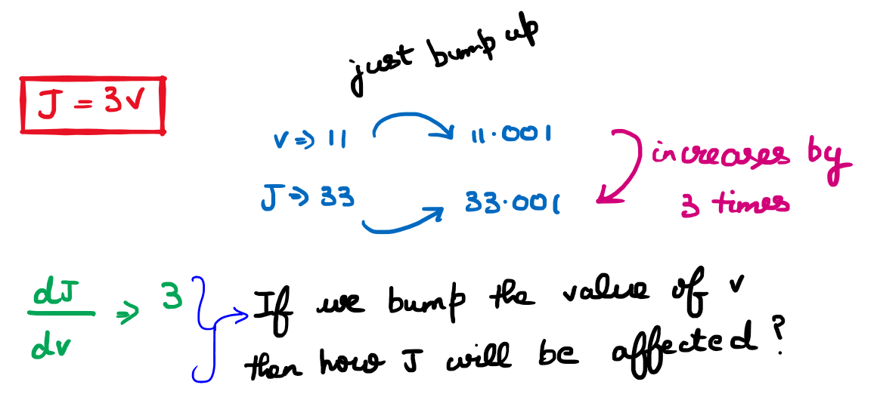

Lets compute dj/da. 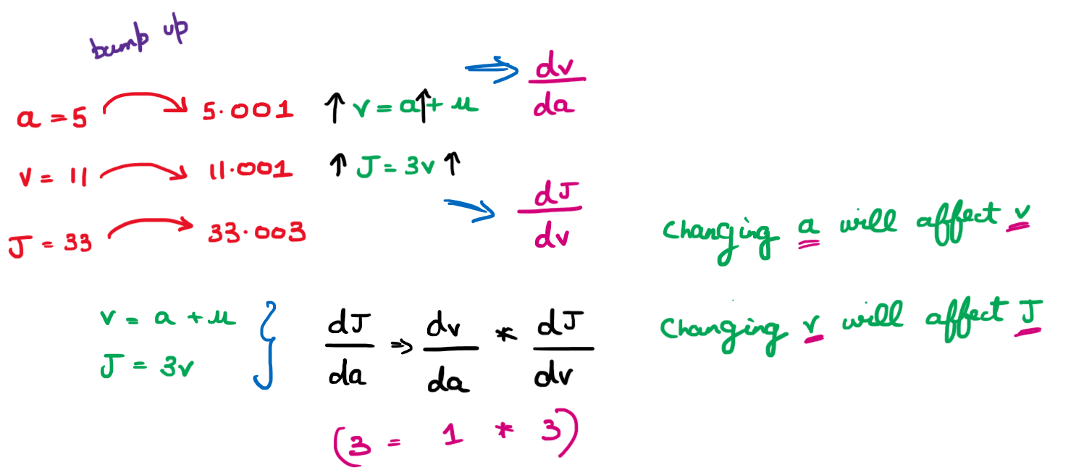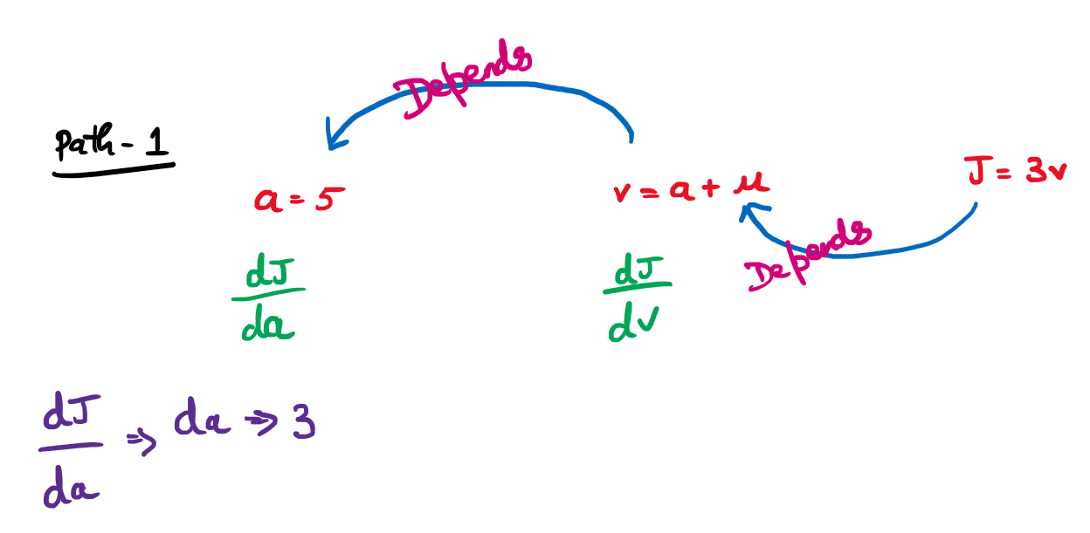

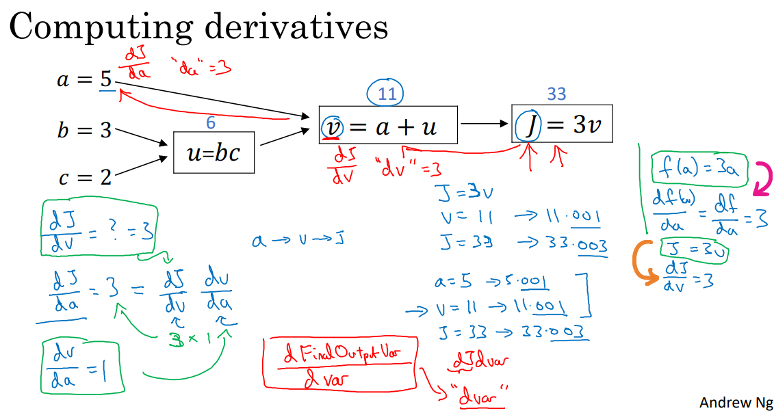

########################################################

Lets compute dj/du.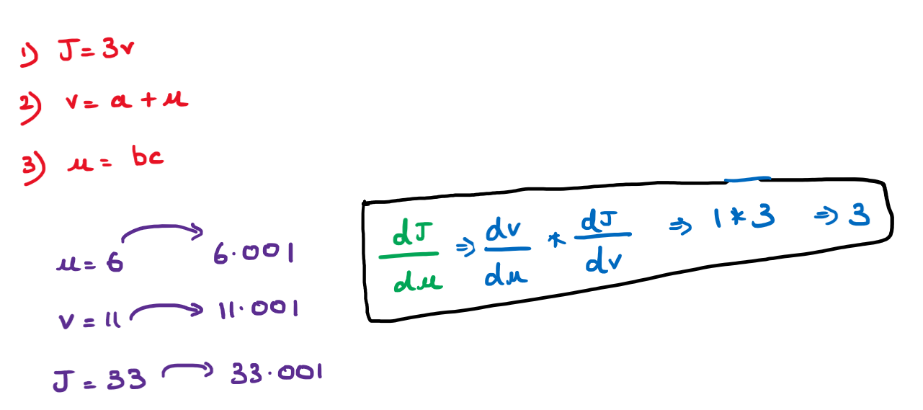

Lets compute dj/db.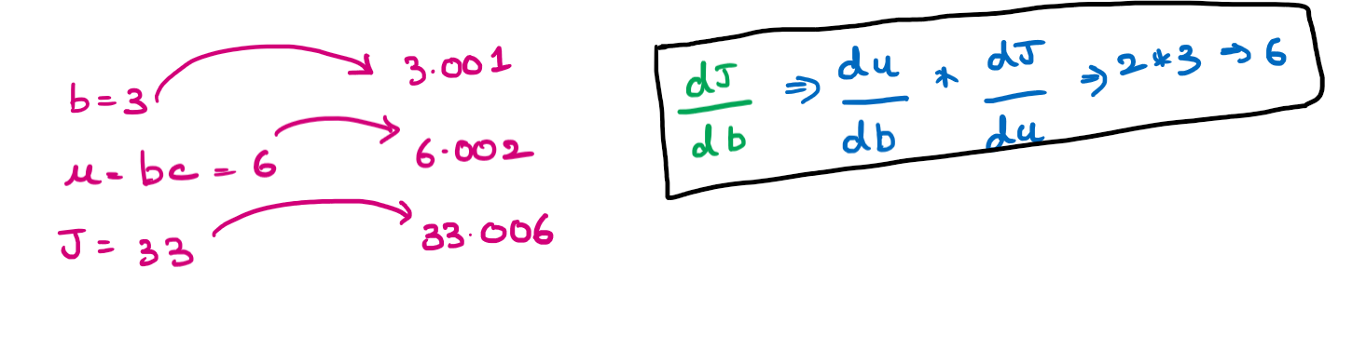

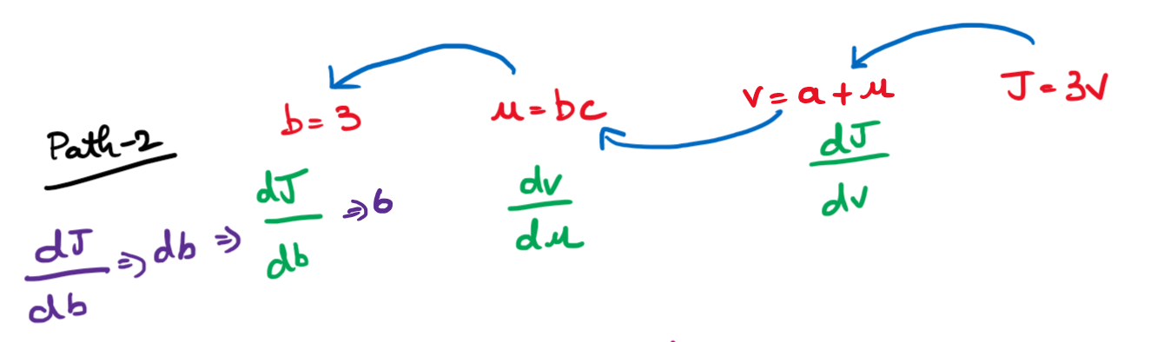

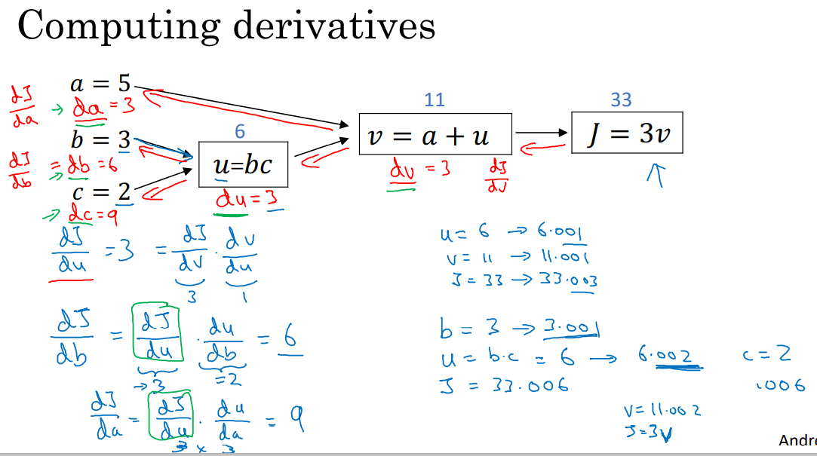

## **Logistic Regression Gradient descent**

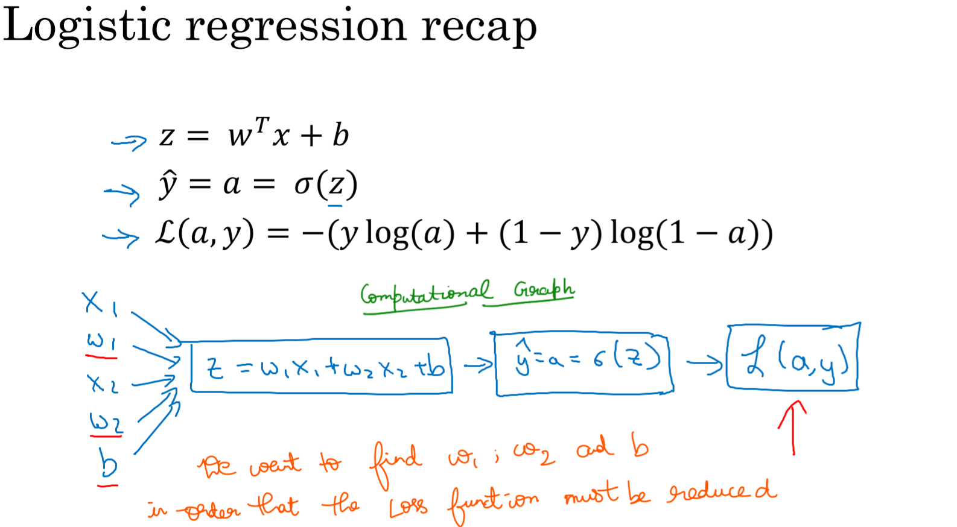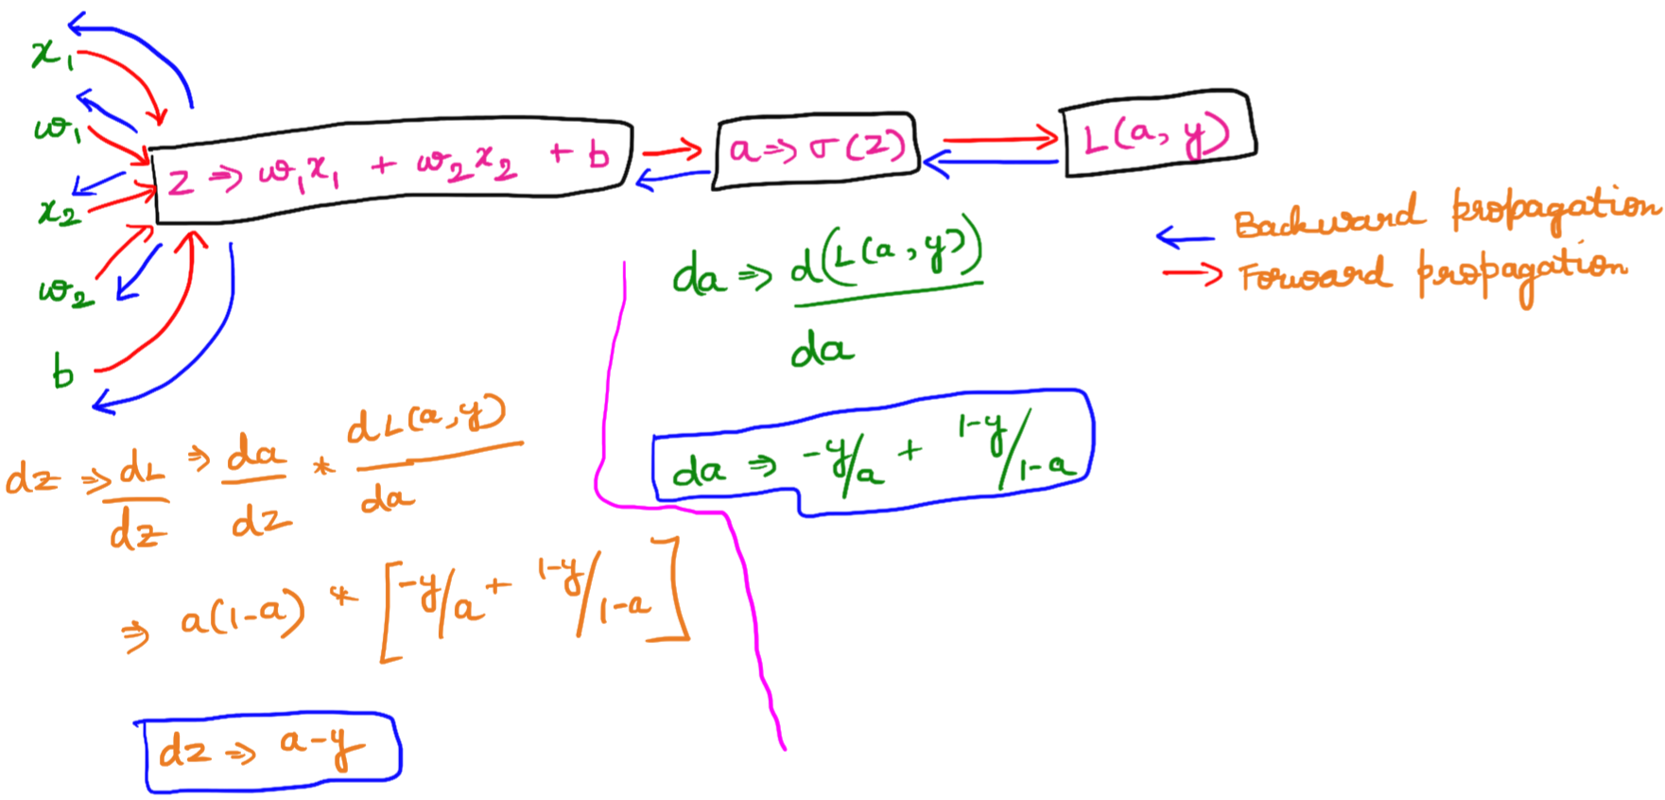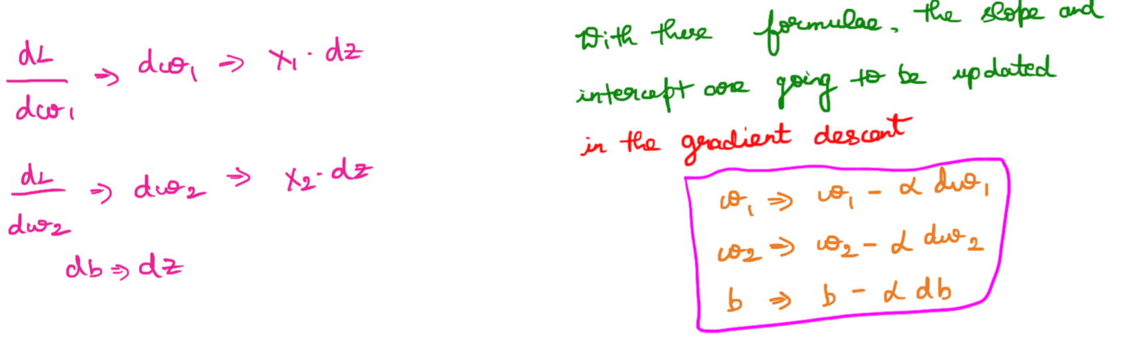

Lets calculate the derivative of Loss with respect to activation function  
(i.e sigmoid function)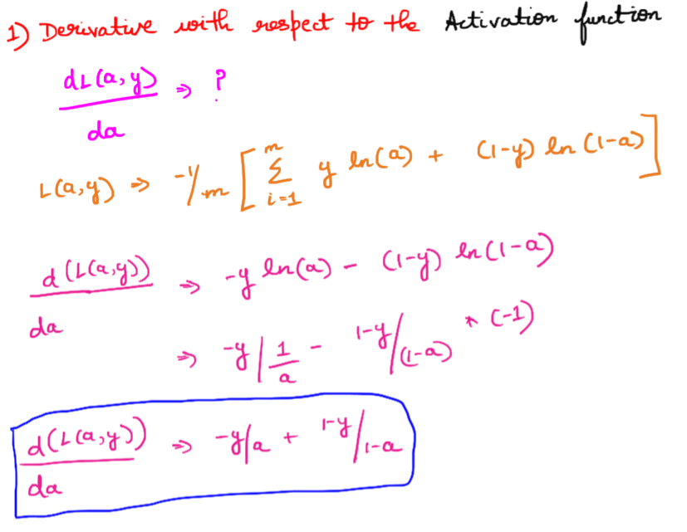  
Lets calculate the derivative of Activation function with respect to dz.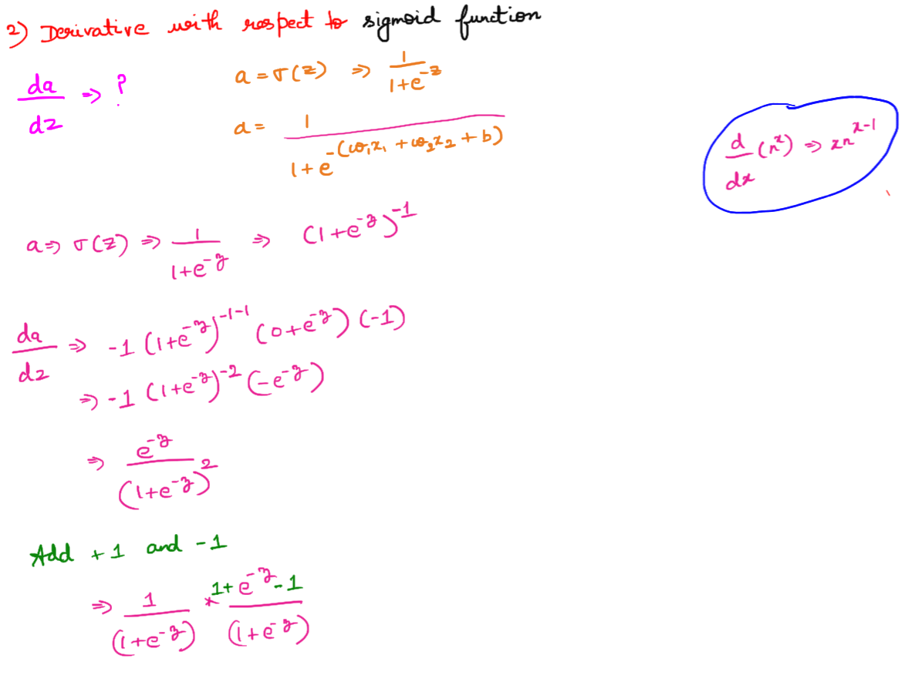

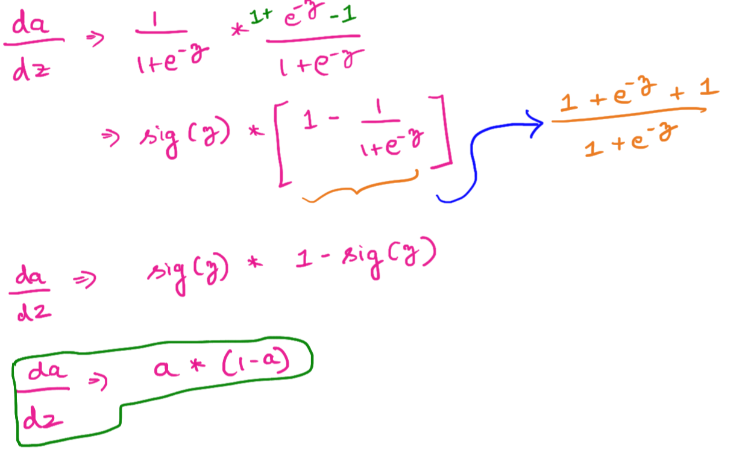

Combining the above derivatives, lets compute the derivative of the Loss function with respect to dz.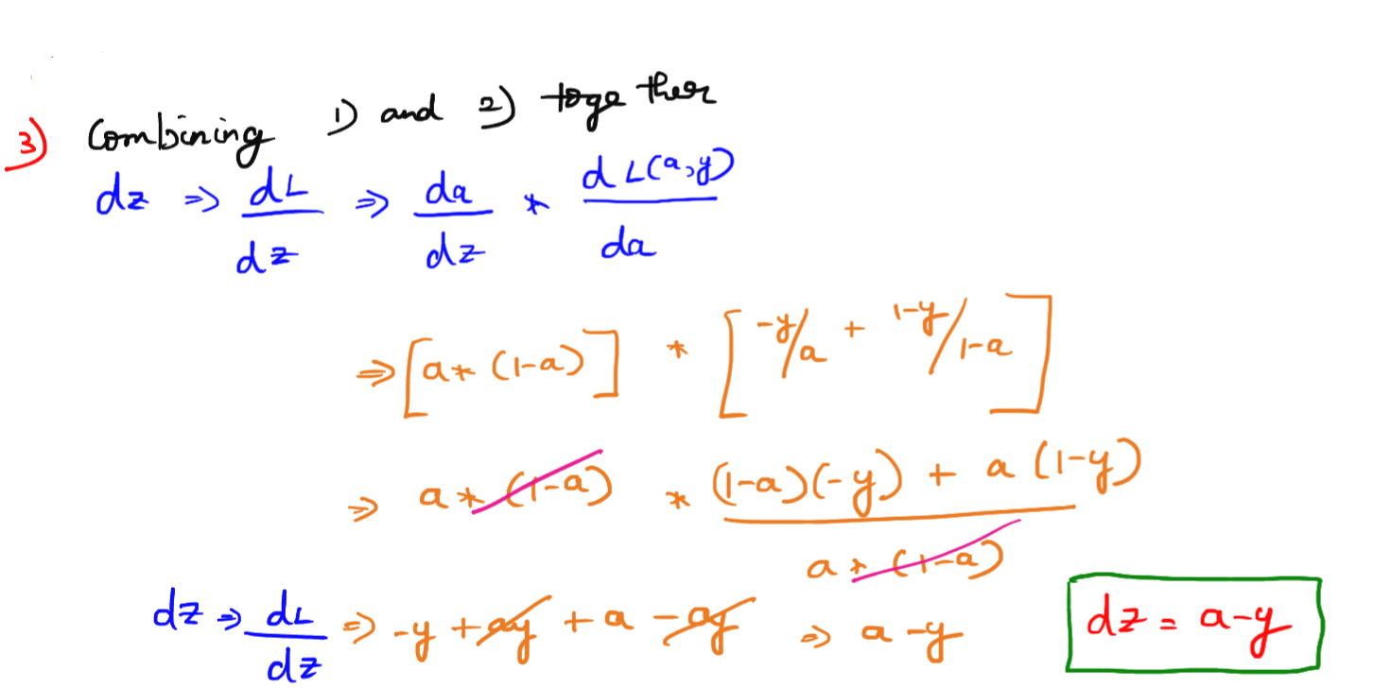

Method-1  
Let’s calculate the derivatives of the Loss function with respect to weighs.  
(Chain Rule)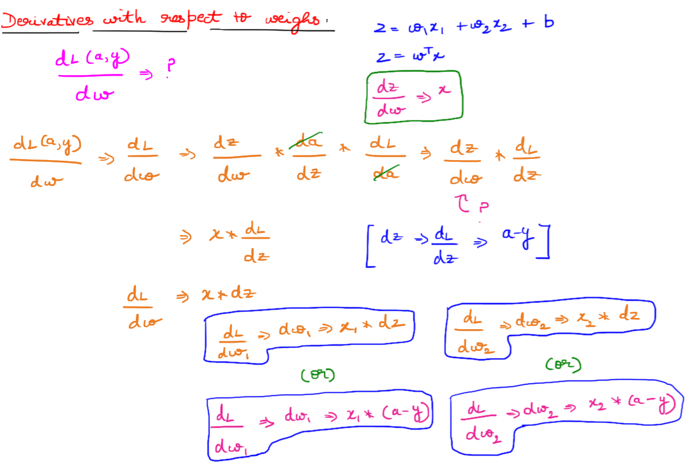Method-2  
The derivatives of the Loss function with respect to weighs can also be computed via Cost function also.  
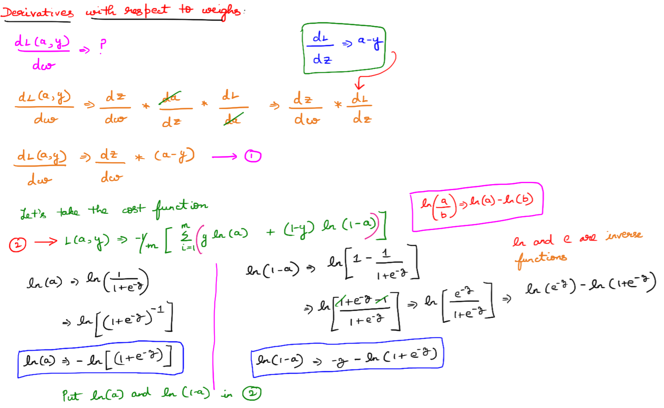

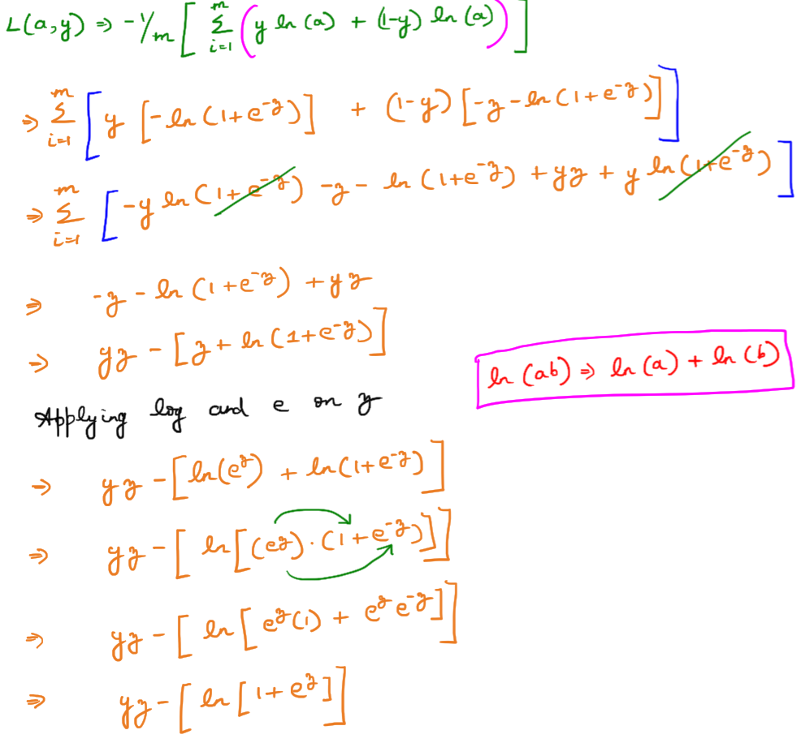  
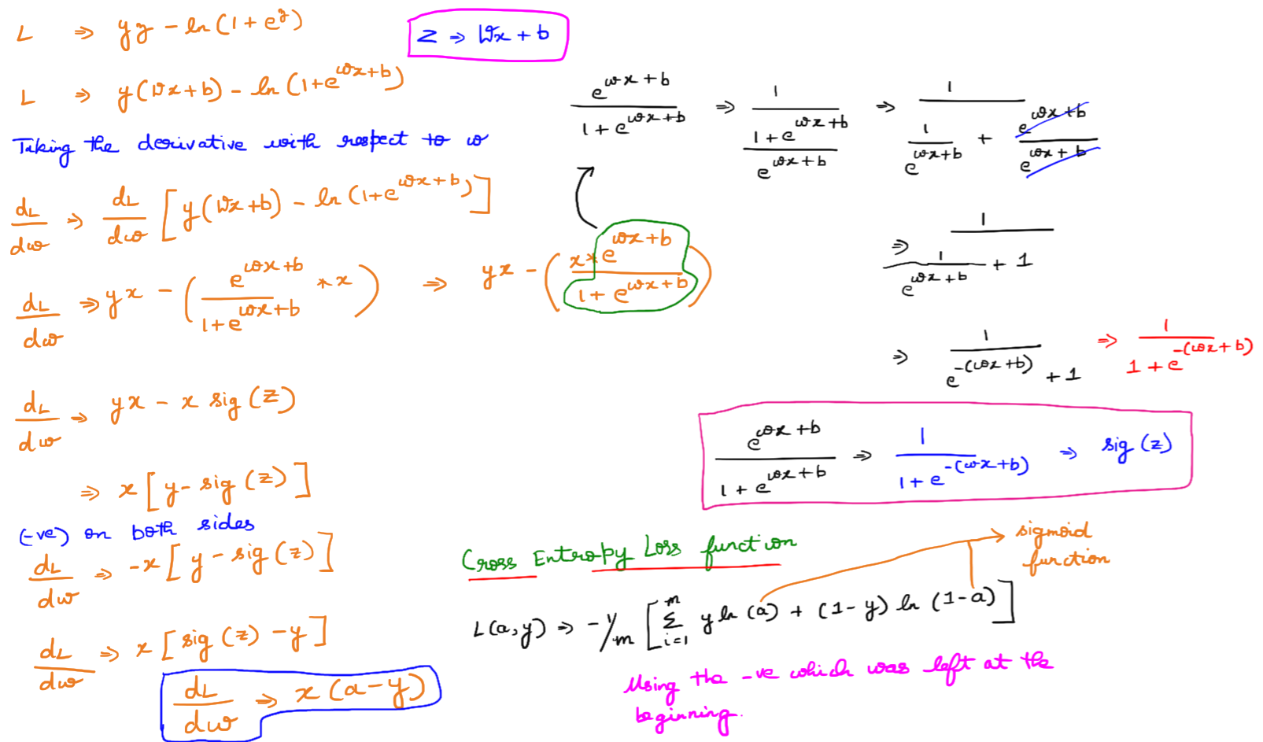

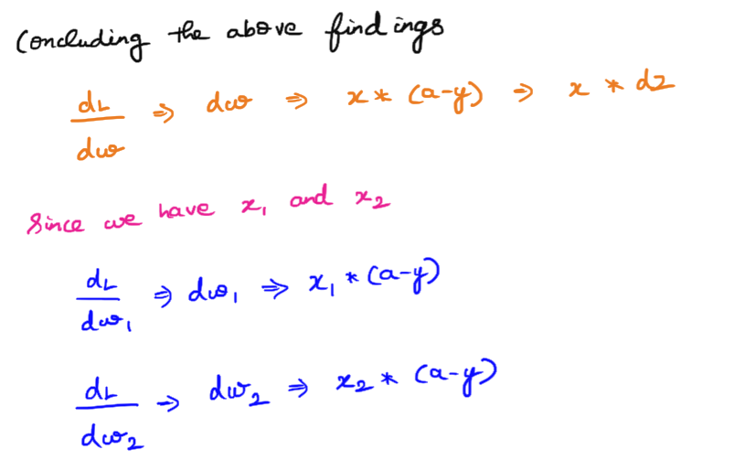

Let’s calculate the derivatives of the Loss function with respect to bias.

## **Gradient Descent on m examples**

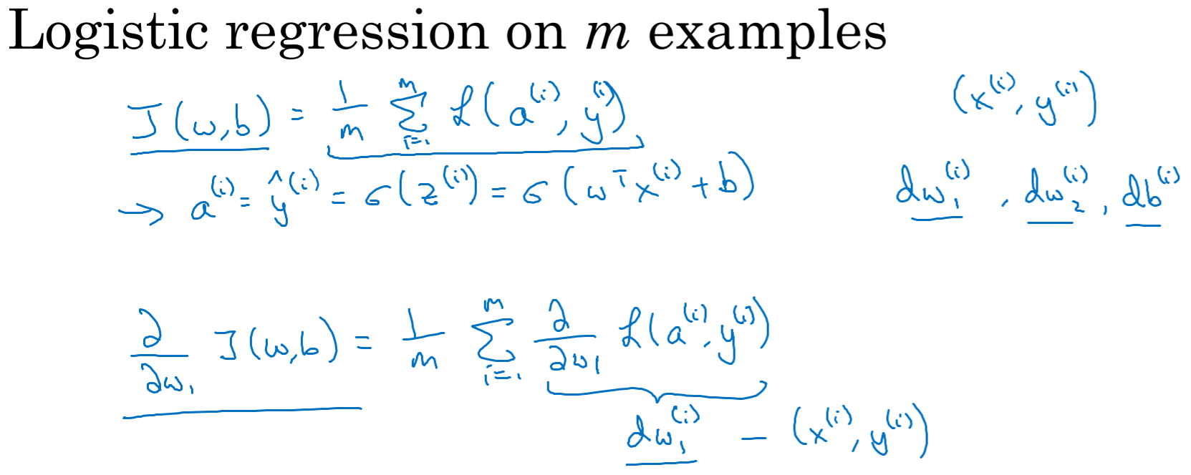

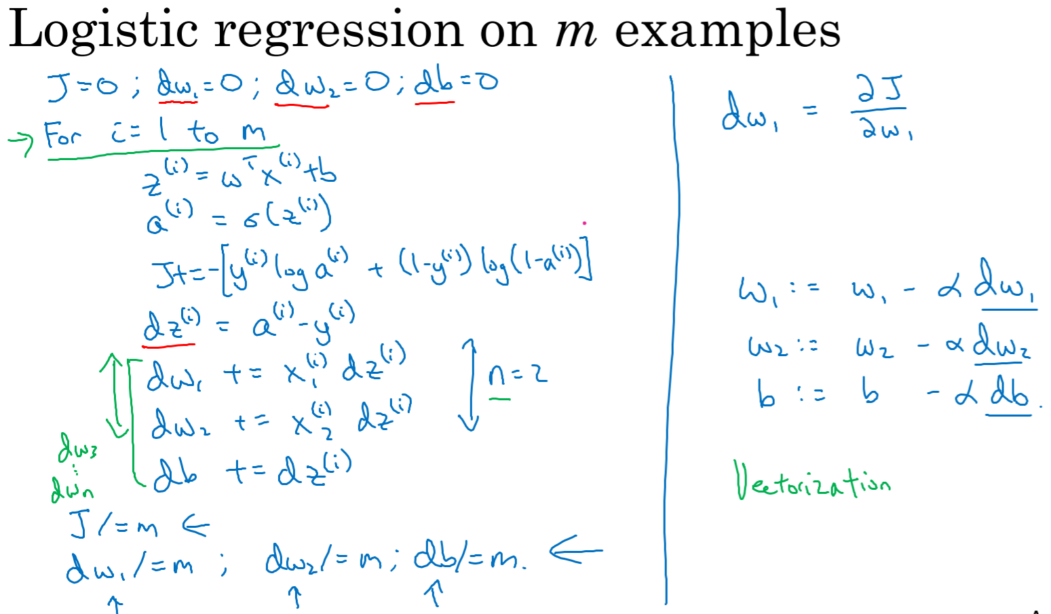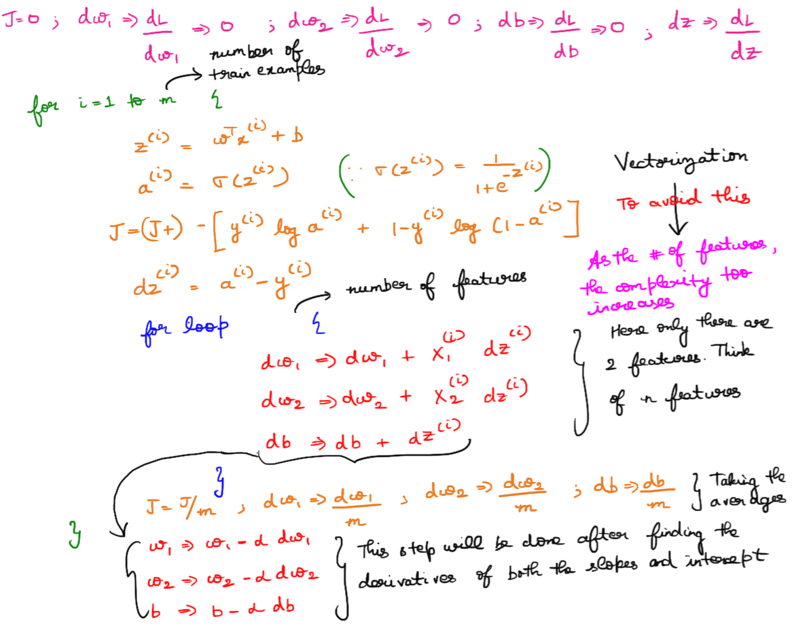

# **Python and Vectorization**

## **Vectorization**

To get rid of for loops, vectorization comes into picture.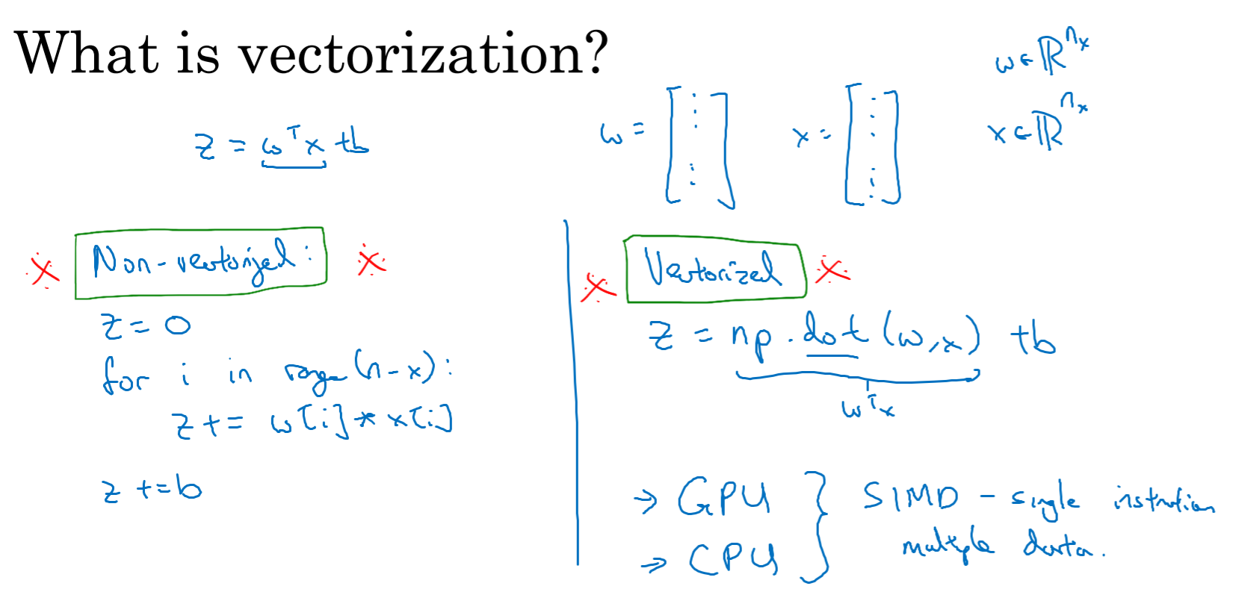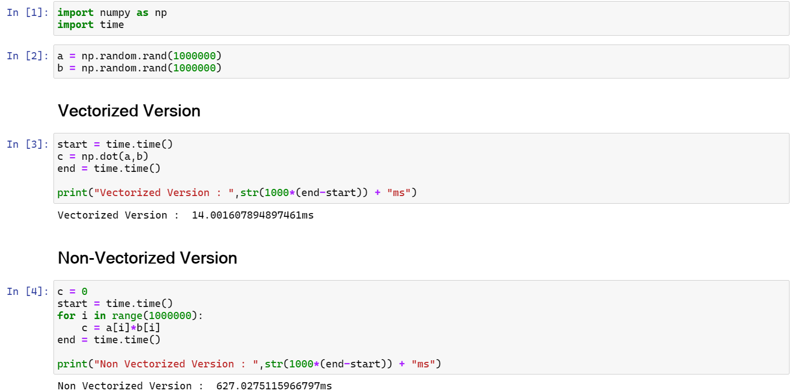

## **More Vectorization Examples**

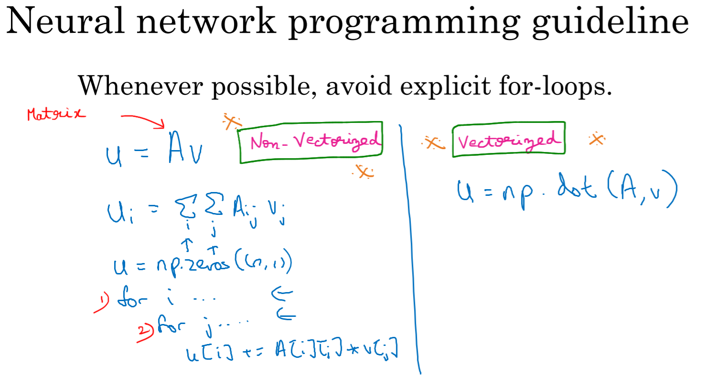  
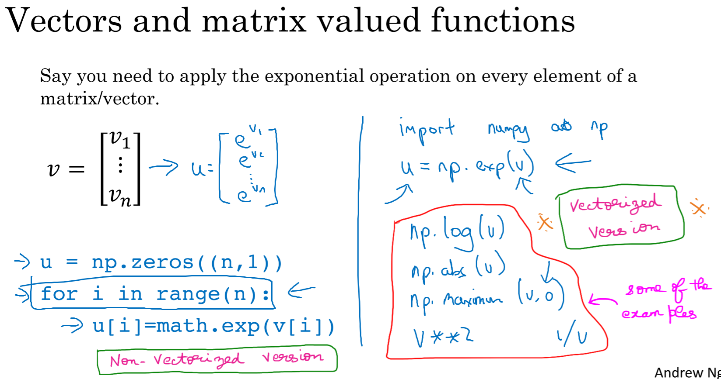Lets see how can we reduce the number of for loops in the gradient descent for Logistic Regression and replace them using Numpy.

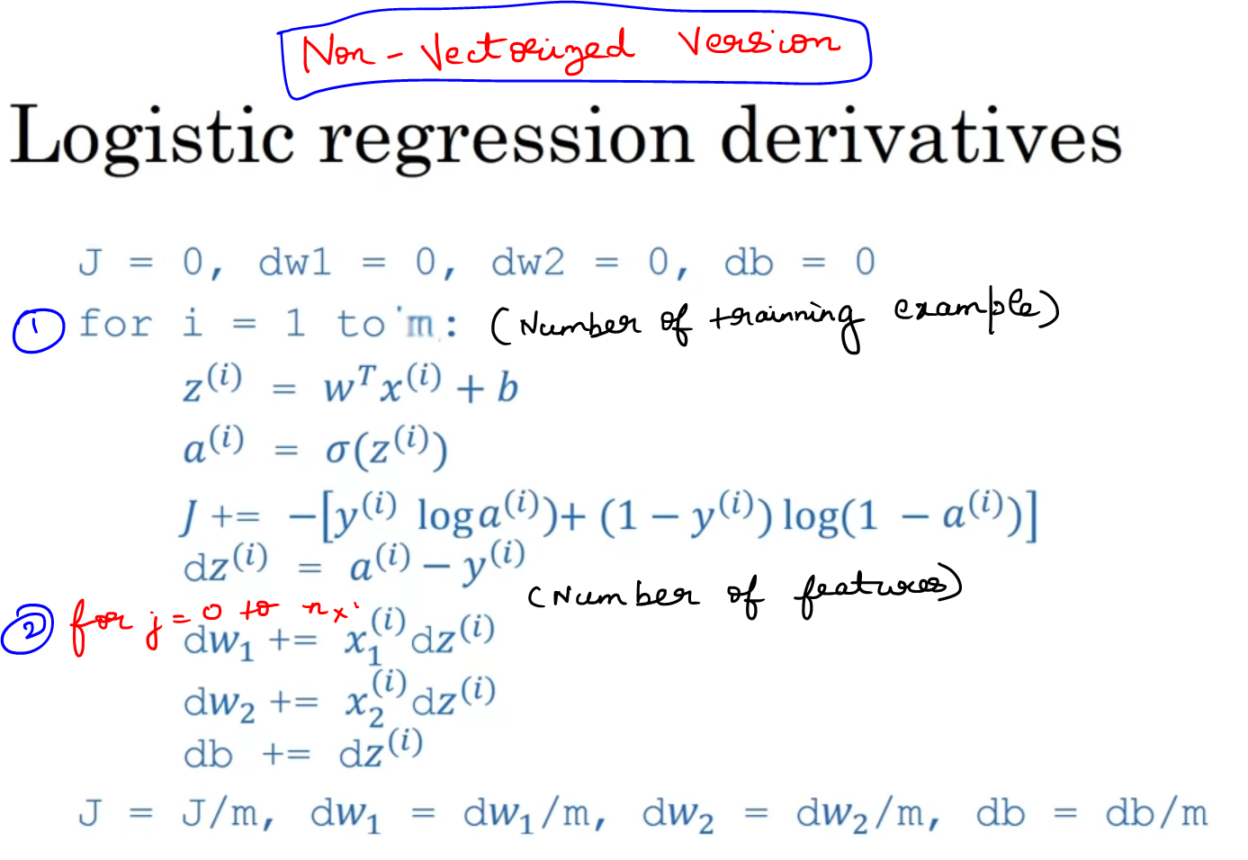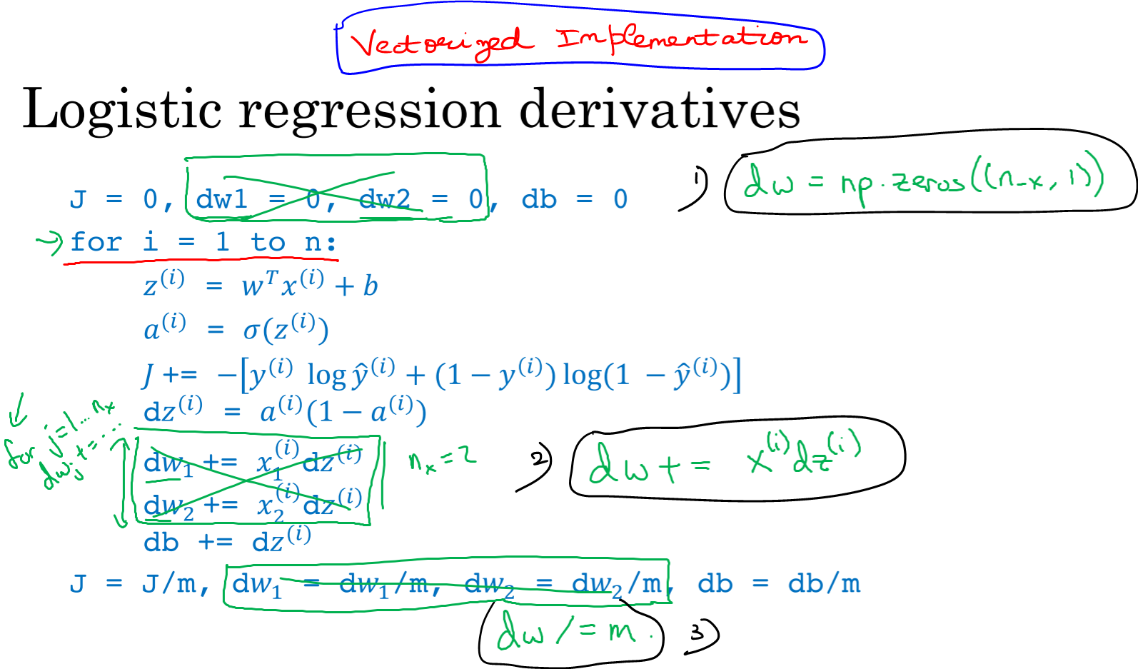

Refer Vectorized Implementation of Gradient Descent.ipynb

## **Vectorizing Logistic Regression**

Let’s see how we can implement the process of Vectorization for the Logistic Regression to implement a single iteration of Gradient Descent to the entire training-set without even using a single explicit for-loop.  
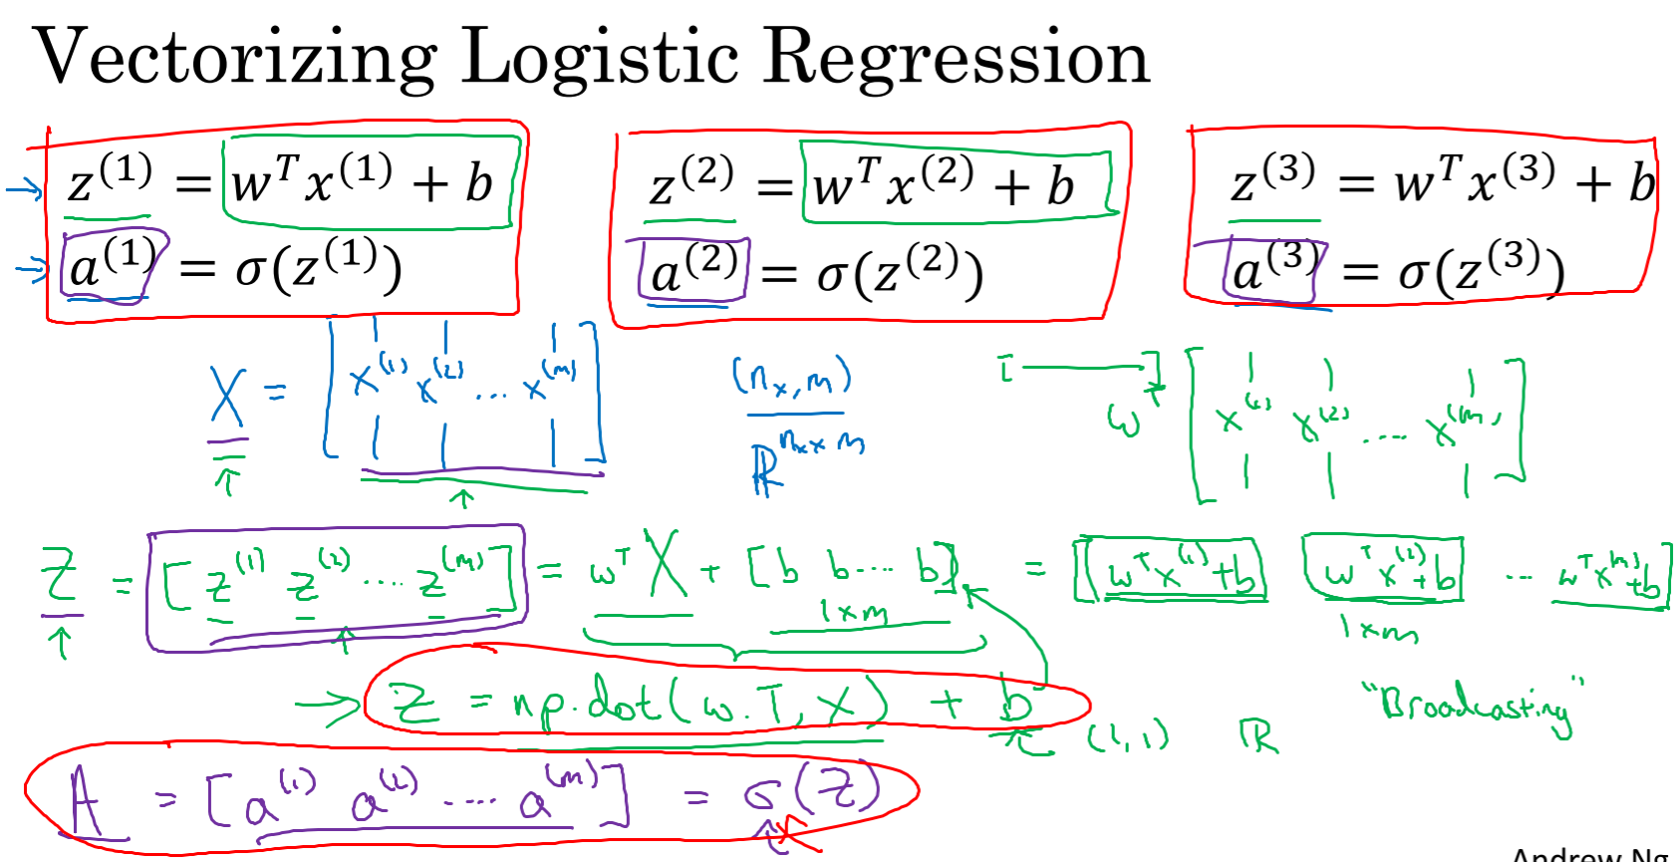Refer Broadcasting in Numpy Arrays.ipynb

## **Vectorizing Logistic Regression’s Gradient Output**

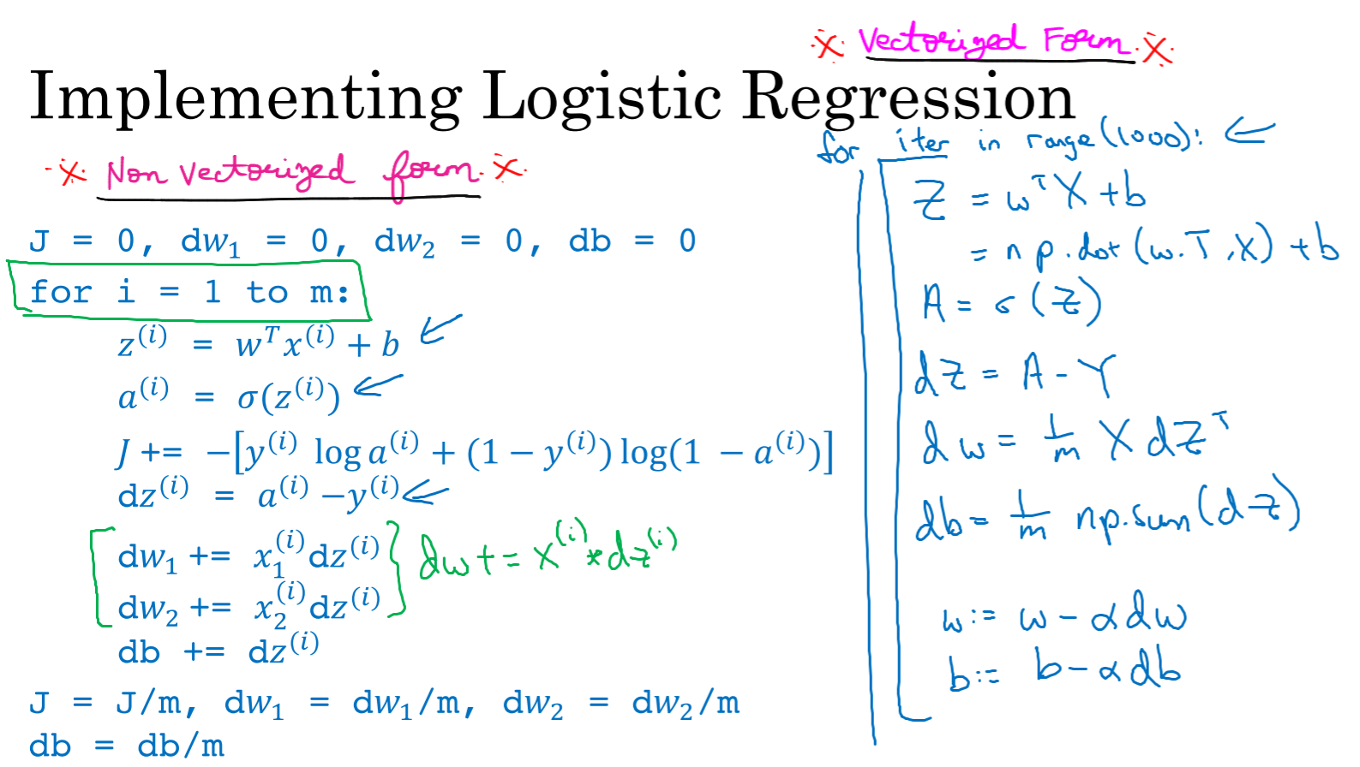

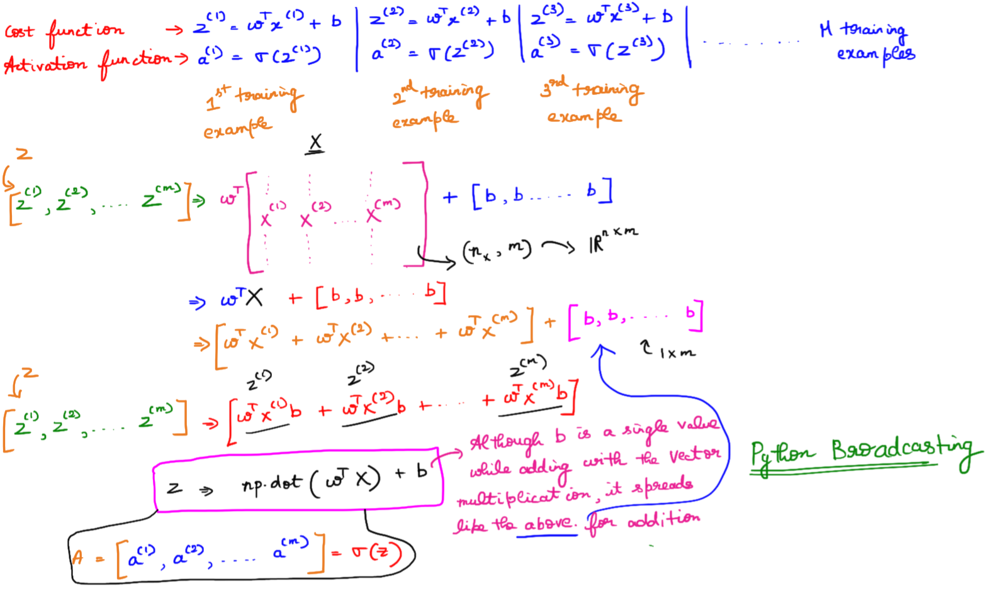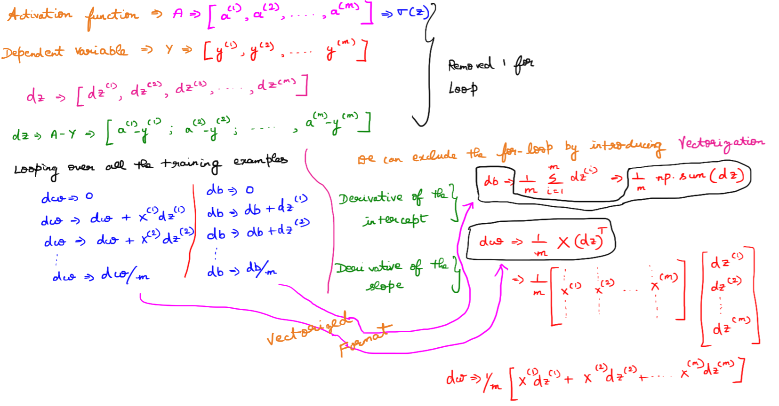

## **Broadcasting in Python**

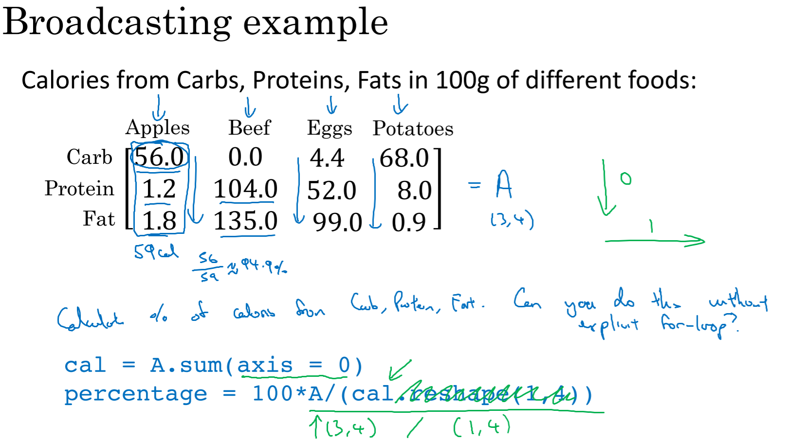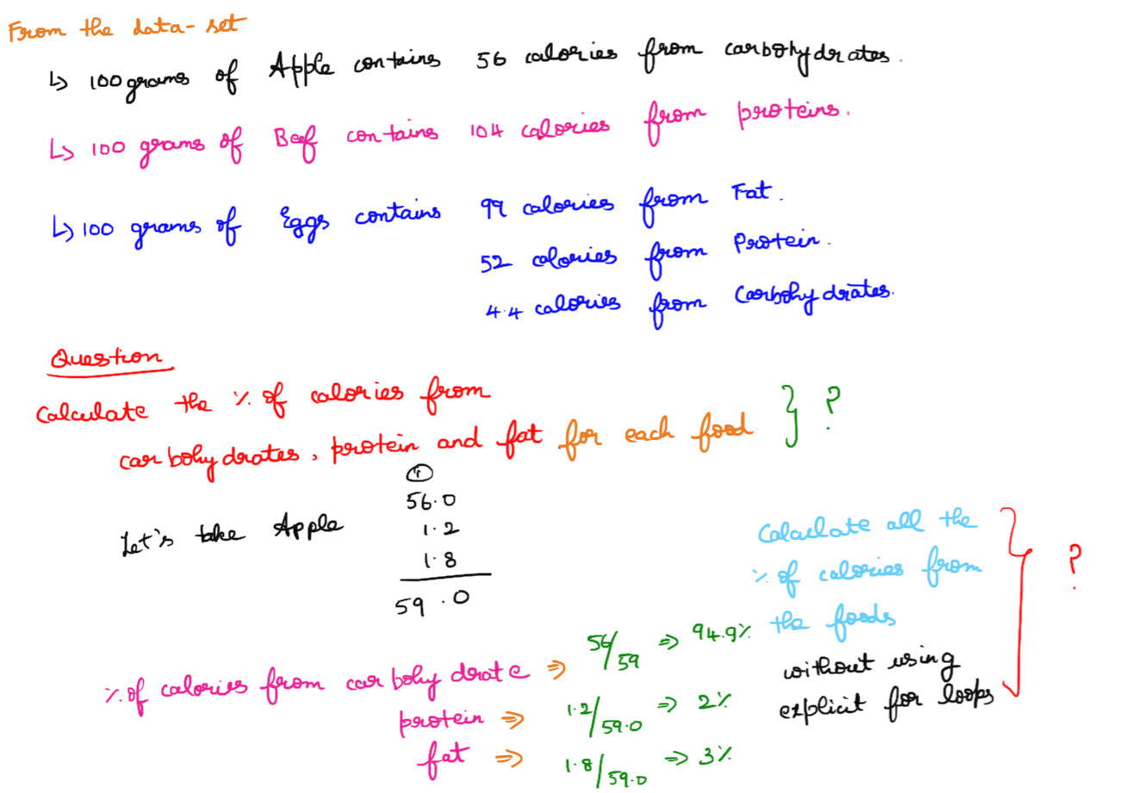

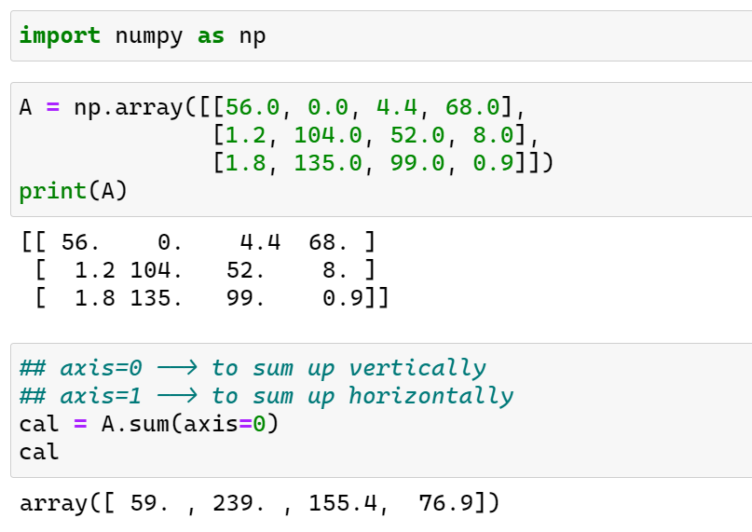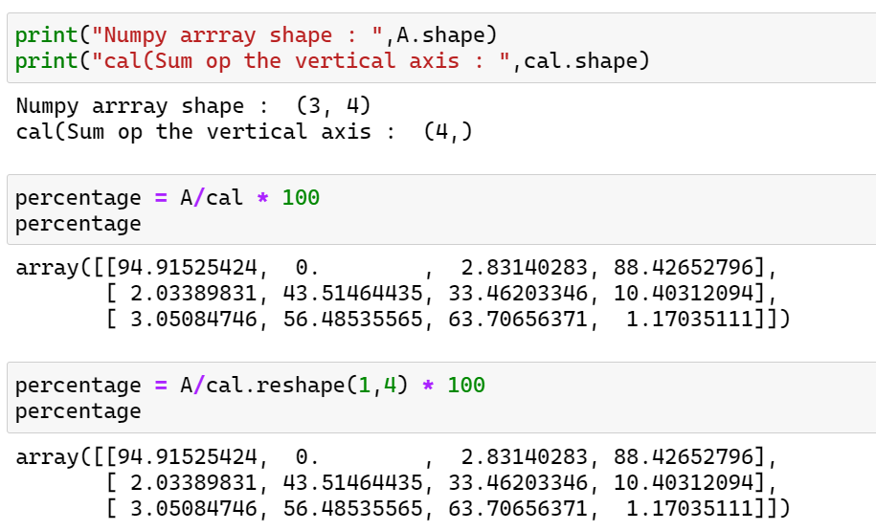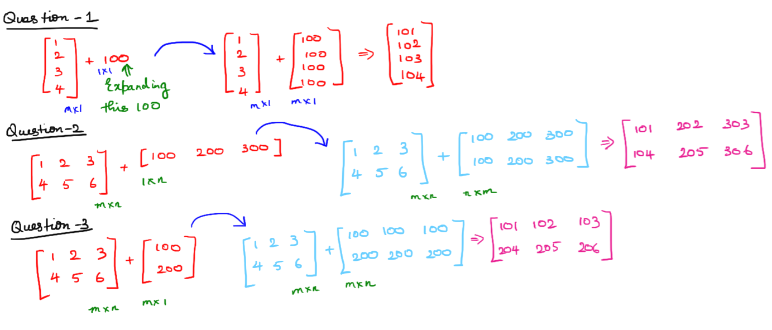

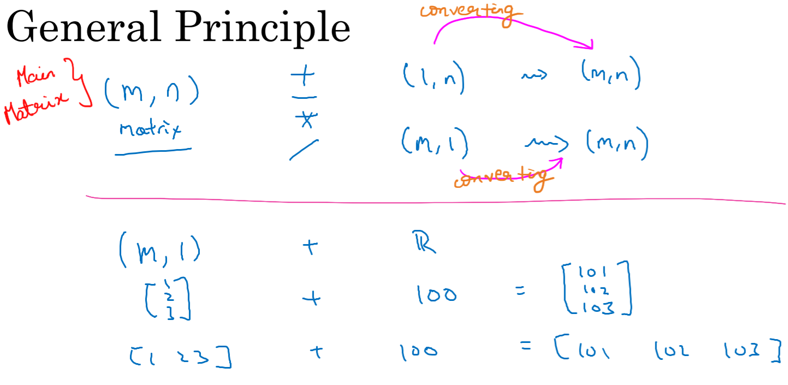

## **A Note on Python/ Numpy Vectors**

Refer inner_and_outer_products.docx

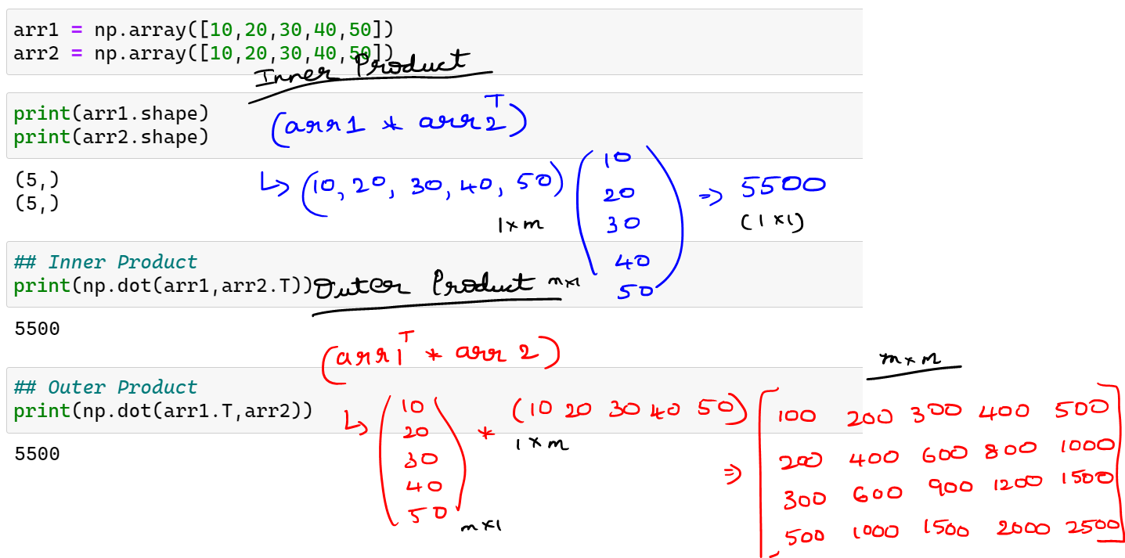

Outer product is not performing correctly. So reshaping the arrays.

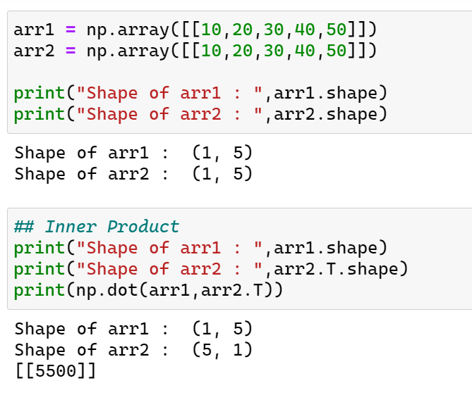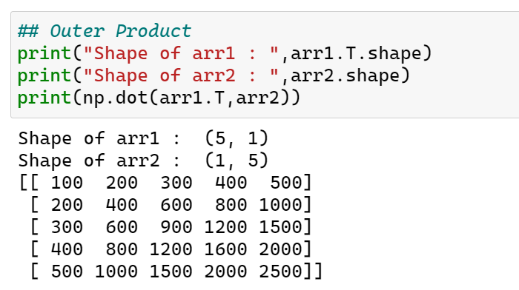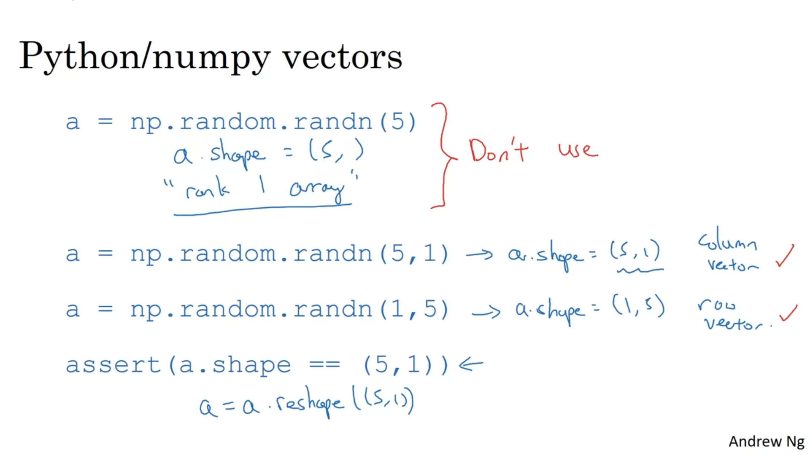

## **Explanation of Logistic Regression Cost Function**

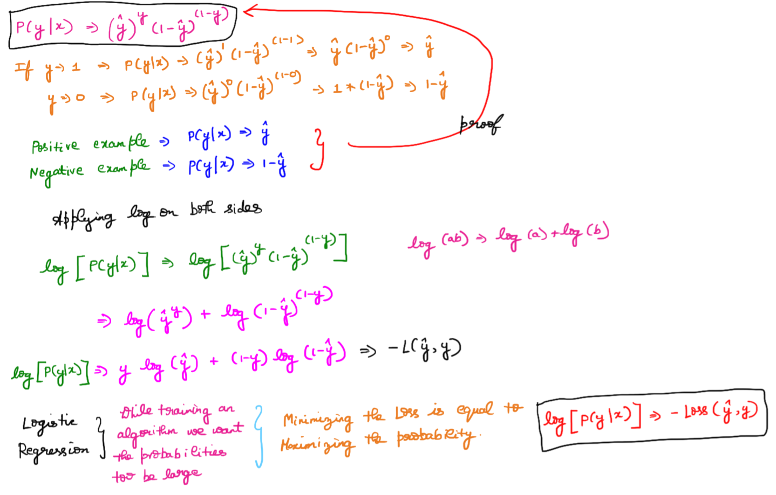  
The above is the loss function for a single training example.

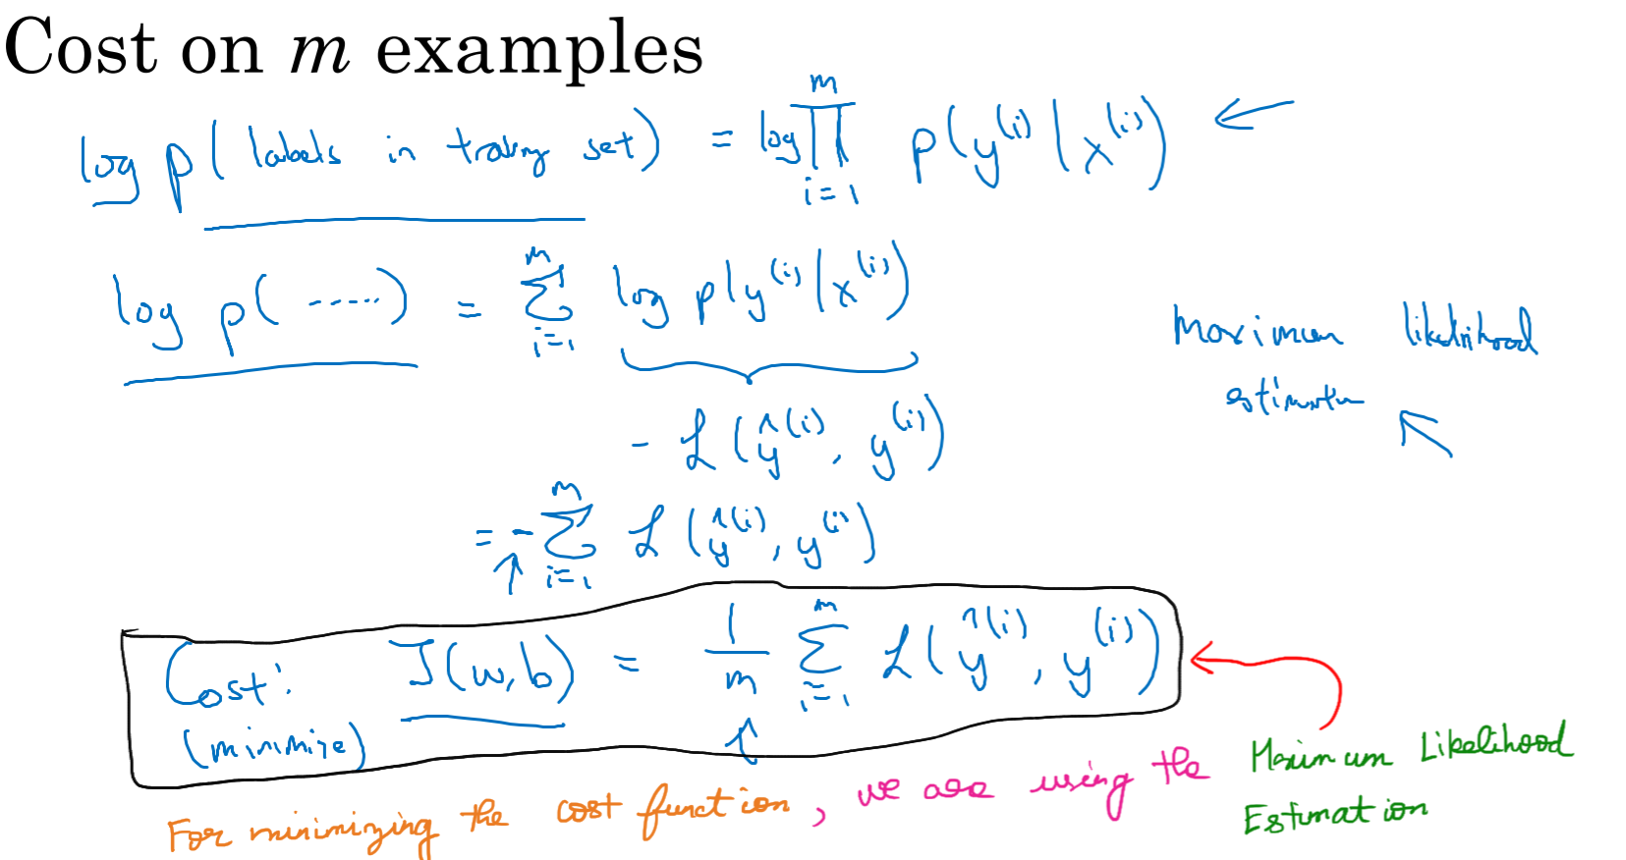

References

<https://medium.com/@pdquant/all-the-backpropagation-derivatives-d5275f727f60>

<https://www.youtube.com/watch?v=ho_QUFrqWOA>